School of Engineering and Technology Industrial Advisory Board
Minutes for Fall Meeting Lake Superior State University
Friday, November 6, 2015

Members Present:
Ray Adams, Bob Andersen, Fred Berg, Tim Bennett, Dave Clingen, Lynnette Eding, Jim Gibbs, Dan Goodrich, Jeff Johnston, Brad Lebouef, Steven Kars, James Kucher, Ralph Larsen, Trevor Swenson, Brian Theriault, Jerry Timm, John Truckey,

LSSU personnel present:
Dr. David Baumann, Eric Becks, Jon Coullard, Dr. David Finley, Dr. Robert Hildebrand, David Leach,
Dr. Andrew Jones, Mark Rodriguez, Jeanne Shibley, and Sanjiv Sinha

Action items from last meeting, May 2015:
- Keep up the contact with the new potential students.
- Add a potential program for Job shadowing and Engineer for a day – anyone interested, please email Dr. David Baumann
- Is anyone interested in joining the Recruitment Committee? Need more members to be active as a committee.
- Next year LSSU should be represented at the “Tech Savvy” event that took place in Gaylord.
- It would be beneficial for IAB members to send examples of various reports and presentations for students to review.
- Next year make it a requirement for each group to do a small video clip to be posted on YouTube or Facebook.

Action items from this meeting will be outlined in red throughout the report.

Business:
- Meeting Called to Order at 8:20am by Steven Kars, Chairman of IAB
- A big THANK YOU to Continental Brimley Development Center for hosting this year’s meeting and for the great spread of breakfast for us all.
- Steve reviewed the Meeting Agenda and we started with a round table introductions on where you work and what you do for your company. Then we ended with a new or strange hobby.

Chairman’s Report
- Steve talked about the 3D printer fundraiser and asked the IAB for donations to help LSSU.
  - This is where the IAB can make a difference. I am reaching out to you to as Industrial Advisory Board Members, Company Owners & Leaders and Supporters of LSSU to help reach our goal of $30,000.00 for this project. LSSU School and Engineering & Technology (SET) has stepped up to fund $5,000 towards this project as well as the SET Faculty & Staff who have raised an additional $1,500 from personal gifts & pledges showing their support.
  - Ideas discussed were these:
    - Finding out what the process is for the Tribe to make donations
    - Working with Local business for donations
    - Make contact with Engineering Alumni to ask for donations
Chairman’s Report, continued… pg. 2

    - Work with Virginia at LSSU foundation to discuss local ideas and Engineering Alum contacts and ideas - Steve
  - Currently we have $6,036.00 remaining to reach our goal! Thank you to those that have contributed already! About 31% of IAB have contributed.
  - Opportunities: $1000.00 Match for 6 x $250.00 donations and $1000 Match for 2 x $500.00 donations.
  - As of December 2015, the goal has been met and the fundraiser is closed.
- Secretary election will take place in spring 2016 meeting. Lynnette has volunteered for this position again.

New Members-
Brad Lebouef, Tony DeMerle, and David Clingen were brought forward as new potential members to the IAB.

Brad works at Systems Control in Iron Mountain
Tony works at Kawasaki Robotics USA, Inc
Dave works at ESSR-Algoma Steel in Sault Ste Marie, Canada

All 3 candidates were voted in to be part of the board.
Dan moved to accept David, Brian 2nd the motion, all approved.
Bob moved to accept Brad, Dan 2nd the motion, all approved.
Brian moved to accept Tony, Jim 2nd the motion, all approved.

Meeting Minutes – Minutes were emailed out prior to the meeting. Lynnette asked if there were any questions from the meeting minutes from the spring 2015 meeting.
Ray moved to approve the meeting minutes, seconded by Fred. No questions were brought up by the board members; motion approved.

Recruitment Subcommittee Report – Trevor Swenson

Smart Zone update – Erick Becks
- There are a couple student LLC’s currently in the SMART Zone.
- Always looking for IAB projects

School of Engineering & Technology Faculty & Staff

Dr. David Baumann – SET Updates
- Overall
  - LSSU: 2,150 (Down from 2,270 last year)
  - SET: 219 (Up from 175 three years ago)
- By Major
BS-CE: 24 BS-EET: 16 AS-GE: 12
BS-EE: 24 BS-MfgET: 39 AS-GET: 4
BS-ME: 97 BS-EMgmt: 2
BS-IT: 1

Dr. David Baumann – SET Updates, continued… pg. 3

- Placement
  - Continues to be strong
  - Recent Career fair
    - 40 Employers (20 hiring Es and ETs)
    - 400 Students (most SET and Business)
    - Robotics and Other
    - Permanent and Internship
- Job Shadowing
  - Prospective students spend a day with one of your engineers.
  - Three prospective students so far
    - AMT
    - JR Automation
  - Aggressively Pursue? Yes!
    - John Truckey and Lynnette Eding have volunteered to do Job Shadowing with prospective students.

- Success stories from Alumni –
  - David can work with recruiting committee to get some.

- New Equipment Received
  - Haas Lathe
    - Value $40K
    - Replaces 32 year-old machine with 18-year controller
    - Complements Haas mill
    - EGME-110 Manufacturing Processes and EGME-312 CAM with CNC Applications

- Senior Project Changes
  - Deadline for Submissions: July 1st?
  - Increase Fee from $4,000 to $5,000?
    - Discussion around this change occurred and it was decided that this would be the set price with option to wave part of fee if company needs assistance. This will be reviewed on a case by case basis, only.
    - In addition, there was discussion on putting a “blurb” in the paperwork for the senior projects about why the increase in cost and what it is covering; putting a positive spin on why we need this increase.

- ABET ETAC Visit
  - Re-Accredit MfgET and Accredit EET (*new*)
  - Request Visit by January 31, 2016
  - Self-Study Reports Due July 1,2016
  - Visit Usually in October
  - IAB Members (especially local) needed for the visit with ABET – will determine what time and where to meet, once that meeting is set up.

- Program Educational Objectives (PEO’s)
  - PEO #1 for MfgET and EET:
    - Graduates having three or more years of experience …
      - 1) … will have demonstrated professional application of technical skills and engineering judgment to solve problems in their profession subject to technical, practical and societal constraints.
Dr. David Baumann – SET Updates, continued… pg. 4

  - PEO #2 for MfgET and EET:
    - Graduates having three or more years of experience …
      - 2) … will have set professional goals, experienced professional growth, and be engaged in ongoing professional development and learning activities.
  - PEO #3 for MfgET and EET:
    - Graduates having three or more years of experience …
      - 3) … will be capable self-learners and make meaningful contributions to society.
- Administrative Support
  - Last Year
    - Shared Dean (SET, Business, PDC)
    - Chair: 25% release + $6,400 stipend
    - ME, ECE, ET Coordinators: $1,800 stipend (each)
    - Robotics Lab: 25% release
  - This Year
    - Lost ECE and ET Coordinators - as a cost savings for the department
      - There was a lot of discussion about this topic
        - Additional $ still comes from enrollment (per credit) and goes directly to the engineering budget
        - All Senior project $ goes to the senior projects budget
        - Besides these, there should not be a cut to lose the ECE and ET coordinators.
        - David has made a list of the activities of the coordinators
        - There has been an increase in students in the Engineering department
(175 – 217)
        - Relating these facts to Liberal Arts: They have built a new building and there is a drop in admissions.
        - The Engineering department is being compared to the Liberal Arts department, where their coordinators may have minimal work. Engineering is completely different.
        - Steve, Bob and Tim will work as a committee to draft a letter to the provost to address this issue.
        - The letter will be reviewed by Steve with the Provost expressing our concern of this cut of the coordinators.
        - Note: Message in the letter must be clear and concise to reconsider the expense for the coordinators.
        - Dan has a motion on the table to create this committee and write the letter, Fred seconded, all approved.

Dr. Andrew Jones – Other SET tasks
- FIRST
  - LSSU investment with FIRST
    - Hosting two events this year:
      - FLL ( practice, tournament – 7 teams)
      - FRC (Kickoff)
    - Regional/State FRC competition presence
    - LSSU Robotic/FIRST scholarships ($8k, 8 students here)

Dr. Andrew Jones – Other SET tasks, continued… pg. 5

  - Changes in future:
    - Changes in FIRST
    - Investigated VEX

- IAB Student Scholarships
  - Charles Snyder IAB Scholarship
    - Endowment available: $58k ($51k in 2011)
      - Spring 2014 offered 4 scholarships:
      - x1 @ $1.5k
      - x2 @ $1k
      - x1 @ $0.5k
    - All students started on campus
  - Planning to offer 4 scholarships for 2015
  - The scholarship makes a difference!

Dr Andrew Jones – ECE Curriculum Updates
- Sustainable Energy Concentration Update
  - 10-12 credit hours:
    - Energy Systems and Sustainability (Fall 2015)
      - 6 students (F14’), 10 students (F15’)
      - Lab, EGNR361 (0,3) , 4 students (F15’)
    - Other classes offered in Spring 2016
      - EGEE411 (3,0) Power Distribution and
Transmission
  - Concentration for EE or CE (future for ME)
- Pending purchase of 10 Oscilloscopes
  - Upgrade one EE lab (controls, power lab)

Introduction and Facility tour of Continental Brimley Development Center – Dan Goodrich
This afternoon’s agenda will commence at LSSU with lunch and some student interaction.

LSSU Student-IAB Interaction
- 2015-2016 Senior Project Synopses
- The students presented a 5 minute presentation of their project
  - SAGA – Steering Alignment Guided Autonomously
  - RVI - Robotic Vision Integration
  - MAC - Machining Automation & Controls
  - 3S – Solar Shade Systems
  - LIFT – Laker Integrated Fabrication Technologies
  - CRS – Crystal Robotic Systems

- Feedback session with the Junior and Senior students.
At this time the IAB members broke in to small groups of 2 IAB members and 2 students and had discussions about Lake State and the Engineering programs and environment they are involved in.
Below are the questions that were asked of the students and the answers that we as a group received from them:

IAB-Student Feedback Session, continued… pg. 6

What has been the best experience while (in the school of Engineering & Technology) at LSSU?
What has been the worst?

Best:
- Working in a team with a real deliverable.
- Liked the teacher’s aide for the programming class and like the creativity challenge.
- Like the rigor to which they are held, in class.
- Like the labs and hands on experience.
- Small college, like the student to staff ratio.

Worst:
- Work load and lots of documentation for the work being done – the students understood why they need to do this, but it was just a concern and a very heavy load.
- Specific classes are only offered every other year – this is an issue for graduation on time.
- Issues with transfer students and the expectations of what should be known for these transfer classes taught by a different intuition.
- PLC is NOT enough equipment to accommodate all students.
- CE – why only C++ and no other languages offered.
- Would like to see an update to the robotics lab
- Statistics teacher is not prepared for class, not really teaching, just working through the problems.
- Wish there was a mid-semester evaluation of teachers for the students

What have you appreciated most about your education (in the school of Engineering & Technology)?
- The professors are a big strength, they will go the extra mile
- The professors are approachable for students.
- Dedication of professors are second to none!
- Very comparable education to other large schools
- No or not many TA’s the professors do the teaching!
- Hands on experience
- Student expressed they felt well prepared for summer work.
- Students do a real project instead of just theory.

Have the computers facilities been sufficient to support your learning? (If so, how? If not, why not?)
- The PLC’s are limited
- The availability of some programs, specifically MS Project and Simulation software is an issue.
- They need to update computers and remove Windows XP.
- Robotics lab chairs need improvement
- Computers are slow.
- Others said labs are great.
- Materials lab needs updates.
- Project for class could not be done due to equipment limitations (pumps on vac).
- It would be nice to have extra hours of access.
- Professors use Y drive and Google, which is great for access to things!

How is the job hunt going? Do you feel supported in your efforts? How was the career fair?
- Job fair was good, but expected more companies.
- Career services talked about resume building.
- Participated in career fair at both LSSU and MTU.
- Computer Engineering – not sure where to look for jobs.
- Facility assistance slanted towards robotics placements.
IAB-Student Feedback Session, continued… pg. 6

- Looking for intern positions for the summer, need help with that.
- Wish they had more time for this, school projects keep them very busy.
- They receive emails regularly.

How have the living options been at LSSU? What percentage of your time have you lived on campus vs off campus?
- Would be good to have key cards to get into buildings or better after hour access for buildings.
- Easy to find off campus housing.
- Prefer off campus, since we don’t leave on breaks.
- On campus is a great facility
- Off campus is cheaper.
- Engineering house is the best. Many people have liked this living arrangement.

What suggestions do you have for improving (the school of Engineering & Technology) LSSU?
- New oscilloscopes
- New robotics labs
- Class offerings and frequency could be better. Not just one time every 2 years.
- Mechanical labs – no composites, mainly steel.
- No math in the morning, example Calc, Diffy Q etc!
- Want to see more computer classes available
- Need better access to library and open later hours.
- Knew could get a job after graduation.
- Affordable.
- Keeping up with technology, they do ok, but could be better.

Business and Engineering Updates
Dr David R Finely, PE Academic Dean

- 3D Printer Campaign
  - We are tantalizingly close to $30,000!

- Enrollment
  - Overall
    - LSSU: 2,150 (down ~500 over four years)
    - SET: 219 (Up from 175 three years ago)
  - By Major
BS-CE: 24 BS-EET: 16 AS-GE: 12
BS-EE: 24 BS-MfgET: 39 AS-GET: 4
BS-ME: 97 BS-EMgmt: 2
BS-IT: 1

  - New Career & Technical Education (CTE) Articulations
into MfgET and EET programs
  - Visits to Community Colleges by Dean
  - Adopt a High School program for faculty
  - New VP for Student Affairs & Enrollment Management
—Matt Jurvelin
  - Pay in-state tuition at Lake State:

Enrollment, continued… pg. 8

- Placement
  - 100% placement rate continues (amazing demand
for graduates)
  - Recruiting for full-time hires begins in Sept. and
Oct. (or even earlier)

- Academic Reorganization
  - Promote cross-discipline endeavors, strengthen general
education
  - Search for College of Arts & Sciences Dean underway
(2 vs. 4 college model)
  - College of Business & Engineering dissolved
  - Academic Dean—Business, Engineering

- South Hall Renovation Project
  - $13.5M renovation to be done June 2016, with ten new all-purpose classrooms, three project rooms, student café and commons, board room, and offices; home to Lukenda School of Business (SET's sister school)

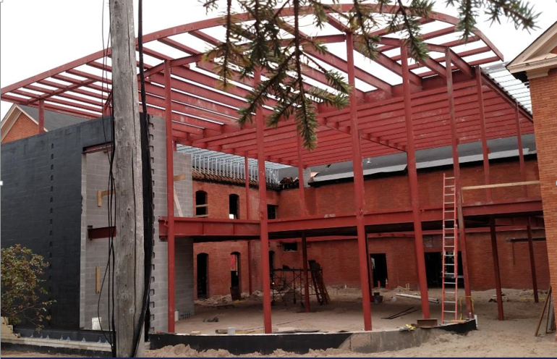

Dr David R Finely, PE Academic Dean – Business, Engineering Updates, continued… pg. 9

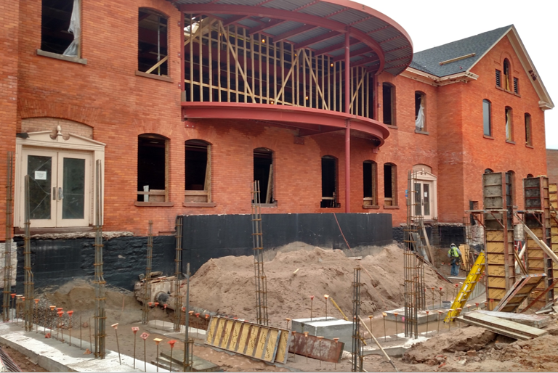

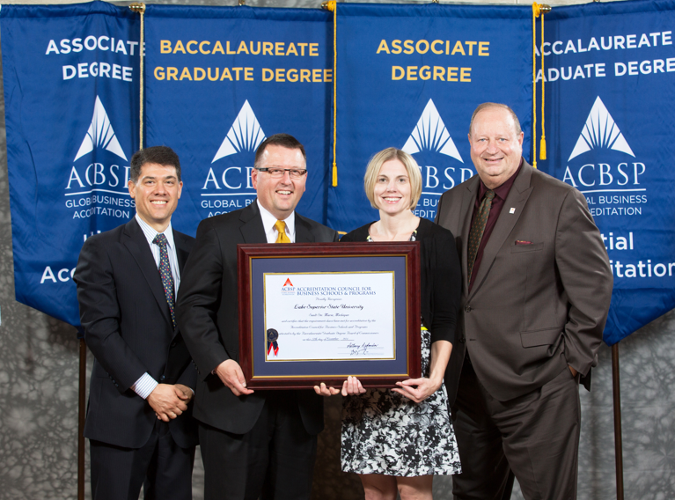

- Next Step
  - Relaunch LSSU Master of Business Administration (MBA) program!
  - Administration (MBA) program!

- Back to SET – New Equipment
  - Four new Fanuc M10 industrial robots
  - New Haas TL-1 Lathe
  - New Stratasys 3D Printer (pending)

- Back to SET – New Chapter
  - ESD (Engineering Society of Detroit) student chapter to be housed at LSSU Engineering House.

- Forward Focus Topics
  - Engineering Economics course into curricula
  - Adopt a High School – “Who is your +1”
    - Example of Adopt a HS – kits being put together to get this going.
  - Professional Practice course into curricula
Dr David R Finely, PE Academic Dean – Business, Engineering Updates, continued… pg. 10

  - Establish Alumni Fellow and Service Award tradition
  - Robotics Lab expansion (capital outlay?)
    - No plans for the Tech Building yet, but there are definitely preliminary plans for the robotics lab.
  - Proposed Civil Engineering major – long term plan
    - Need lots more planning, but this school is a great location, due to the bridges, locks, water, etc.
    - Need correct financial backing
    - Ray mentioned that a study was done with a consultant a while a go about small schools and battling budgets. There is potential to rob Peter to pay paul by adding more curricula.

Summary of all action items from this meeting:
- Work with Virginia at LSSU foundation to discuss local ideas and Engineering Alum contacts and ideas – Steve
- Job Shadowing – any additional volunteers for this? Let David Baumann know.
- Alumni success stories - David can work with recruiting committee to get some.
- IAB Members (especially local) needed for the visit with ABET – will determine what time and where to meet, once that meeting is set up.
- Steve, Bob and Tim will work as a committee to draft a letter to the provost to address this issue.
- The letter will be reviewed by Steve with the Provost expressing our concern of this cut of the coordinators.

Closing Remarks:
- Next meeting: LSSU Campus on April 29, 2016

Respectively Submitted,

Lynnette Eding
LSSU IAB Secretary

