
School of Engineering and Technology Industrial Advisory Board
Meeting minutes for Spring meeting at Lake Superior State University
on Friday, May 2, 2008

Members Present:
Dave Allison, Bob Andersen, Fred Berg, Nathan Callaghan, Chris Conklin, Darryl Dinel, Lynnette Eding, Jim Gibbs, Steven Kars, Charlie Litzner, Adam Lyon, Ernest Maas, Brian Theriault, John Truckey, Don Stephanic, Dick VandeVussse, Gary Walker

Guests Present:
Steve Bryan

LSSU Personnel:
David Baumann, Eric Becks, Jim Devaprasad, Paul Duesing, Robert Hildebrand, Andrew Jones, Wael Mokhtar, David Leech, Jeanne Shibley, Morrie Walworth

Opening:
Fred Berg opened the meeting and welcomed everyone to Lake Superior State University for graduation weekend 2008.

The previous meeting minutes were emailed to all members in addition to being posted on the LSSU website.
The action items from the November 2007 meeting were briefly reviewed:

Action Items from November 2007 meeting: Responsible

New groups are needed for Early January time frame to host an open house. All Members

Do we want to create a subcommittee to enhance Professional Development? Ralph Shoberg

The action items reviewed and minutes were accepted as stated for the November 2007 meeting.

All action items from the current meeting will be listed in RED in the meeting minutes below.

IAB updates from the Chairman

IAB Members on the Move
  - Marty Zoerner- LexaMar
  - John Truckey- Precision Edge
  - Dan Goodrich- Continental Teves
  - Gary Walker- Jordan Iron Works
Welcome Back
  - Matt Witte – Chrysler
Corporate Retirement
  - Chris Conklin-Dow Corning

Secretary election took place at this meeting. This was the first time in IAB history to have a secretary election. We appreciate the people who volunteered for this position. The nominees were: Nathan Calaghan, Lynnette Eding, and Marty Zoener. After a vote by the IAB board members, Lynnette won the election as Secretary for another term of 2 years.

Secretary Report
A new membership status and information update sheet was given to all members to complete to verify we have the most current information on the database. Lynnette will update the database and determine the status of all the members via email and update sheets. See attachment for example of sheet.

New candidate approval:
One new candidate was presented to the board, Steven Bryan. He was a guest at the meeting, so he stepped out of the room at the time of voting.
The motion was made by Bob Andersen to accept Steven to the board and all agreed.

Subcommittee Updates:
Recruitment subcommittee-

The Recruitment Programs are:
- MACRO events
- Direct Contact Support
- Manufacturing Open House Event Support

MACRO Event Program:
- There were fewer MACRO events this past fall and fewer IAB support at the events that did take place.
- There was a 100% increase on questions about engineering.
- Chris will email the latest MACRO events to everyone. In addition, the list is on the LSSU website.
- Chris’ email is Chris.conklin@att.net since he will be retiring from Dow in June.
Action item: If anyone knows of any local trade shows that we can attend to represent LSSU, please let Chris know.

The Direct Contact Support program:
- Nothing new to update on this program

Manufacturing Open House Event Support Program:
- We need some new volunteers to lead program.
- Daryl D will make come phone calls to robot shops to see if they would be willing to host an open house.
Action item: New groups are needed for Early January time frame to host an open house.

LSSU School Updates
- New LSSU Administration
- New School Staff
- Enrollment
- IAB & Admissions

New LSSU Administration:
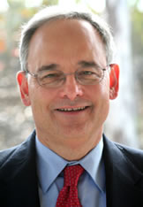 President
  - Started in October
  - Dr. Rodney Lowman
    - Ph.D. Psychology

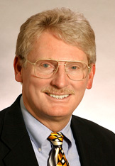 Provost
  - Started in April 2007
  - Dr. Scott Amos
    - Ph.D. Engineering

New School Staff:

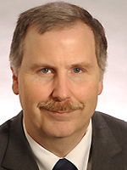 Prototype Development Center
- Eric Beck (M.S. Electrical Engineering)

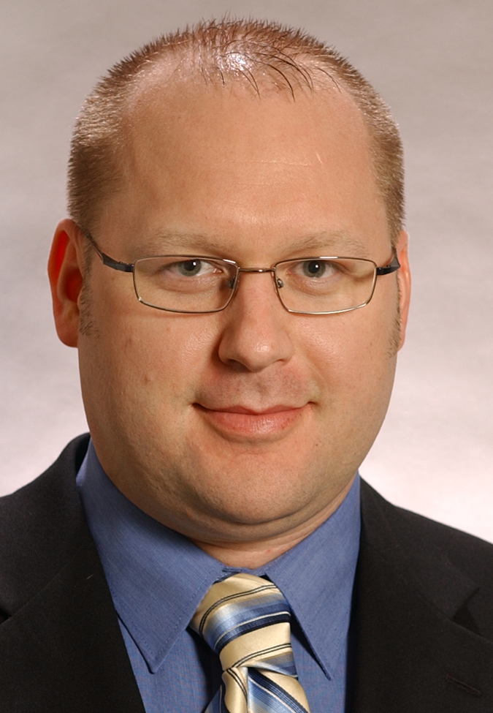 Prototype Development Center
- David Leach (B.S. Mechanical Engineering)

Secretary
  - Anne Babinsky has left
  - Cheri Skinner will start May 5th

Faculty
  - Keith Schwiderson is retiring
  - Taskin Padar, PhD is leaving

Enrollments
- Admits are reasonable, considering enrollment has been down over the past 6-8 years.
- Enrollment begins in May
- Aggressive calling/e-mail campaign
- New initiatives with Admissions
  - Early scholarship awards – by May they were all distributed
  - Automated mailings – to begin this summer

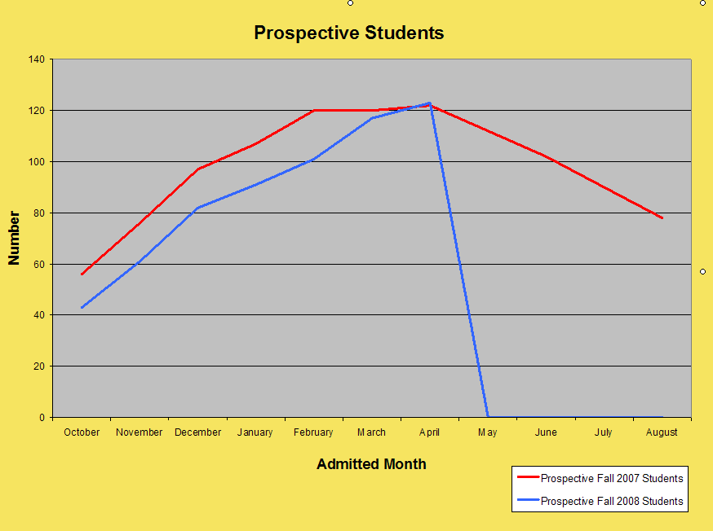

IAB Involvement in Admissions
  - MACROA Events- Outside intervention by an IAB member not employed by the University has been and continue to be widely accepted as a positive image by the potential candidates and their parents.
  - Need IAB businesses to sponsor Open Houses
  - Calling Students
    - Faculty Call First
    - Then IAB members could be called to participate in updating calling sheets

Prototype Development Center (PDC)

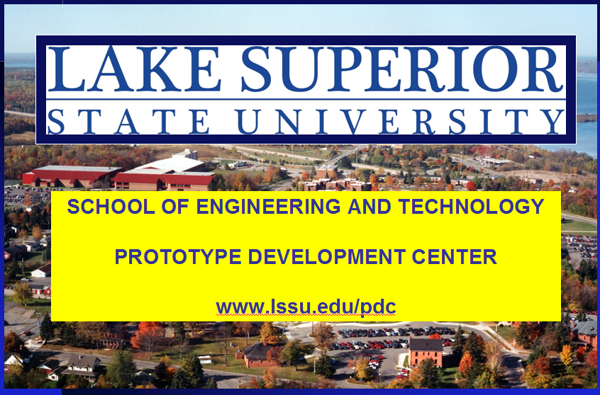

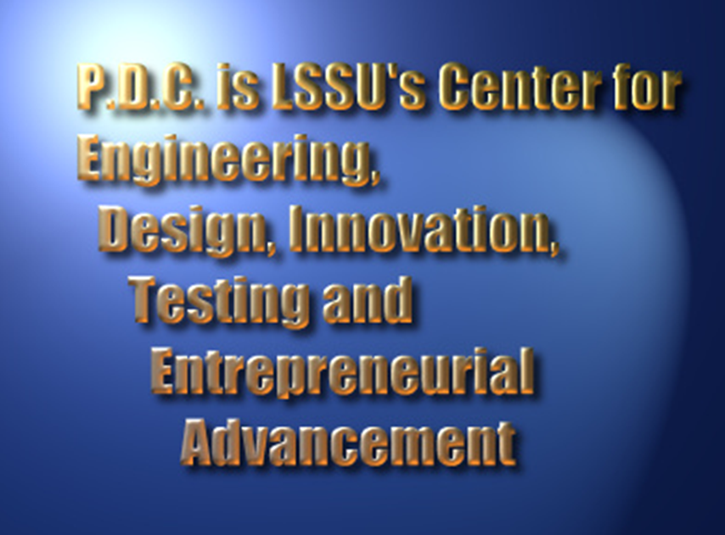



The PDC is focused on applying the resources of the LSSU School of Engineering and Technology to practical projects supporting entrepreneurs and businesses – ultimately aiding Michigan’s economy.

These resources include:
- Facilities
- Facility
- Project managers (David and Eric)
- Students
All of Lake Superior State University

The engineering services the PDC can provide are:
- Design/analysis
- Prototyping
- Product and process development
- Product and process testing
- Data acquisition
- Research
- Training -- on-Campus or on-site

Current capabilities of the PDC:
- Software Design
  - Embedded Systems
  - Application Software
- Electrical Design
  - Design For Manufacture
  - Circuit design & analysis
  - Printed Circuit design
  - Surface Mount Technology
- CAD/CAM/FEA . . .
  - 3D Solids modeling software
  - Rapid Prototype
- Automation and controls
  - Staubli, Fanuc, Adept robots
  - Delmia simulation software
  - Cognex vision systems
  - Allen Bradley PLCs
  - RSLogix software
  - PanelBuilder software
- Manufacturing processes
  - Hardinge and Victor CNC
  - Witness factory simulation and analysis
  - EDM machining
- Materials testing
  - Tinius Olsen compression/tension/shear
  - Rockwell, Brinell, Microhardness
- Zeiss ~ Eclipse / C M M

Future capabilities of the PDC:
- CAD/CAM Enhancements
  - 3D Laser Scanning
  - Reverse Engineering
- Manufacturing processes
  - Wire EDM machining
  - SMT Circuit Assembly
- Materials testing
  - Eddy Current flaw detection
  - Ultrasonic surface flaw detection
  - Potential collaboration on SEM

Some current activities of the PDC:
- Metallographic analysis for Algoma Tube
- FEA for new construction technology
- Design and RP of recreational vehicle accessories
- Develop proposals in support of manufacturing startup
- Monitoring system for industrial processing
- Design & RP for several local entrepreneurs
- Software – Hardware – Packaging design
for patented consumer sports product
- Consulting on senior projects
- Investigation of manufacturing process improvements
- Metal fatigue investigation - crack propagation
- Working with EDCs and MISBTDC
- Hosting local manufacturing group meetings

Why partner with LSSU PDC?
Low Cost
  - Non-profit entity
  - Students who will soon be in engineering jobs
  - Faculty and experienced engineers at reasonable rates

Convenient
  - Fast response
  - Ease of interaction
  - Facilities and special equipment not found elsewhere in the area

We encourage
  - IAB Members
  - Alumni
  - Senior Project Sponsors

To mention the LSSU Prototype Development Center when projects arise in the service areas of:
  - Engineering
  - Design
  - Testing / Verification
  - Prototyping
  - Documentation
  - Process development, automation and improvement

FE Exam
LSSU uses the pass rate from the FE exam as a record for the ABET accreditiation.
An FE Review Course is offered:
- Objectives:
  - A review for our students
  - ABET Accreditation
- Team-taught by SET faculty
- Every spring semester
- ME, EE seniors
- Technically free

Below is an example of the review course schedule:
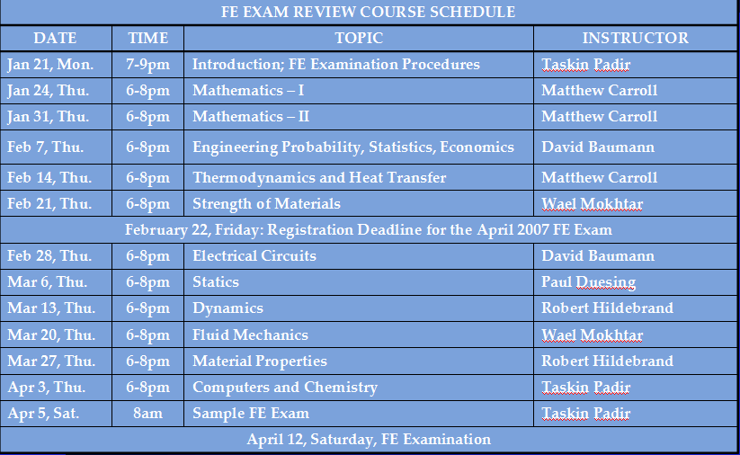

Future Directions for the FE Course:
  - Continue to offer the course
    - Beneficial to our students
    - Beneficial to SET
  - Advertise/advocate widely
  - Online offerings
  - Expand the coverage

LSSU Program Updates
Mechanical Engineering Options:
Grade “C” or better for the options:
A grade “C” or better for all courses in the Vehicle Systems and Robotic and Automation options is required.
EGNR310 Advanced Quality Engineering:
EGNR 310 (4 credits) is added to the list of courses the students can take to meet the requirements for the General Mechanical option.
EGME442 Finite Element Analysis:
EGME 442 (4 credits) is replaced by Vehicle Instrumentation EGEE365 (4 credits) for Vehicle Systems option.
EGME410 Vehicle Development & Testing:
EGME410 (1.5 credits) is changed to
GME310 (2 credits).
EGME411 Vehicle Dynamics:
EGME411 is changed from 1.5 to 2 credits.
Pro-E CAD Package:
Pro-E will be used for CAD, FEA and CNC courses.
EGEM320 Dynamics:
The number of credits for EGEM320 Dynamics is reduced from 4 to 3 credits.

Electrical Computer Engineering Options:

- New Vehicle Systems course finalized
- Options finalized
- Decision on software made (sort of)

EGEE-365 (3,3) Vehicle Instrumentation
20% Vehicle systems, sensors, and controls
20% LabView programming fundamentals
10% Data acquisition and hardware interface
10% Overview of CAN and other networks
25% CAN-based instrumentation
15% MATLAB-Simulink simulation

David McDonald is looking for some different parts that will interface with the CAN network. Please contact David if you have any ideas for him.

Electrical Engineering Options
Robotics and Automation
EGRS-385 (2,3) Robotics Engineering (C or better required)
EGRS-430 (3,3) Systems Integration and Machine Vision (C or better required)
EGRS-435 (3,3) Automated Manufacturing Systems (C or better required)
Digital Systems
EGEE-320 (3,3) Digital Design (C or better required)
EGEE-355 (3,3) Microcontroller Systems (C or better required)
EGEE-425 (2,2) Digital Signal Processing (C or better required)
Electrical/Mechanical
EGEM-320 (3,0) Dynamics (C or better required)
EGME-225 (3,0) Mechanics of Materials (C or better required)
EGME-337 (4,0) Thermodynamics (C or better required)
Vehicle Systems
EGEE-365 (3,3) Vehicle Instrumentation (C or better required)
EGEM-320 (3,0) Dynamics (C or better required)
EGME-310 (1,2) Vehicle Develop and Testing (C or better required)
EGME-411 (2,0) Vehicle Dynamics (C or better required)

“General”

Electrical Engineering Software
Circuit Simulation - PSpice (student version)
- Easy to use
- Free
- Decision made
Board Layout - Eagle
- Successfully used on two senior projects
- Must purchase
- Decision pending PDC recommendation

Computer Engineering Options:
New CS course added
CSCI-122 (3,0) Programming Tools and Techniques
Formerly: CSCI-121 C++ and programming techniques
Now: CSCI-121 C++
CSCI-122 programming techniques and C
CSCI-122 (3,0) Programming Tools and Techniques
Formerly: CSCI-103, CSCI-105, CSCI-121, CSCI-201, CSCI-221, CSCI-341 (19 credits)
Now: CSCI-105, CSCI-121, CSCI-122, CSCI-201, CSCI-221, CSCI-341 (19 credits)
Robotics and Automation
EGRS-385 (2,3) Robotics Engineering (C or better required)
EGRS-430 (3,3) Systems Integration and Machine Vision (C or better required)
EGRS-435 (3,3) Automated Manufacturing Systems (C or better required)
Control Systems]
EGEM-220 (3,0) Statics C or better required)
EGRS-460 (3,3) Control Systems (C or better required)
EGRS-461 (3,3) Design of Control Systems (C or better required)
“General”

NSF Opportunities
- National Science Foundation (NSF)
  - $5,600,000,000 ($5.6B) awarded per year
  - 10,000 awards per year
- NSF Grant Writing Workshop
  - David Leach (PDC)
  - Wael Mokhtar (MEMfgET)
  - David Baumann (ECE)
  - New provost and five others from LSSU
- Possible Grants
  - STEM Talent Expansion Program (STEP)
  - Course, Curriculum, and Laboratory Improvement (CCLI)
  - Major Research Instrumentation (MRI)
  - Grant Opportunity for Academic Liaison with Industry (GOAL)
  - Research in Undergraduate Institutions (RUI)
  - Faculty Early Career Development (CAREER)
- Statistics
  - Average grant around $500,000 ($500K)
  - About 30% of grant proposals approved
- Paraphrases from NSF Workshop
  - “All other things being equal, we’d be more likely to approve a proposal from a community college than a major research university.”
  - “We like to increase diversity, including geographic diversity.”

Senior Projects
- Recent Senior Projects History
- Current 2007-2008 Projects
- Presentations and Demonstrations
- Request for 2008-2009 Projects
Also Information on Summer Camps

RECENT SENIOR PROJECTS HISTORY
- IAB Connection
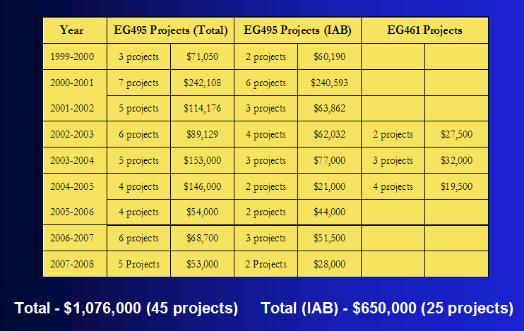

Current 2008 Senior Projects:
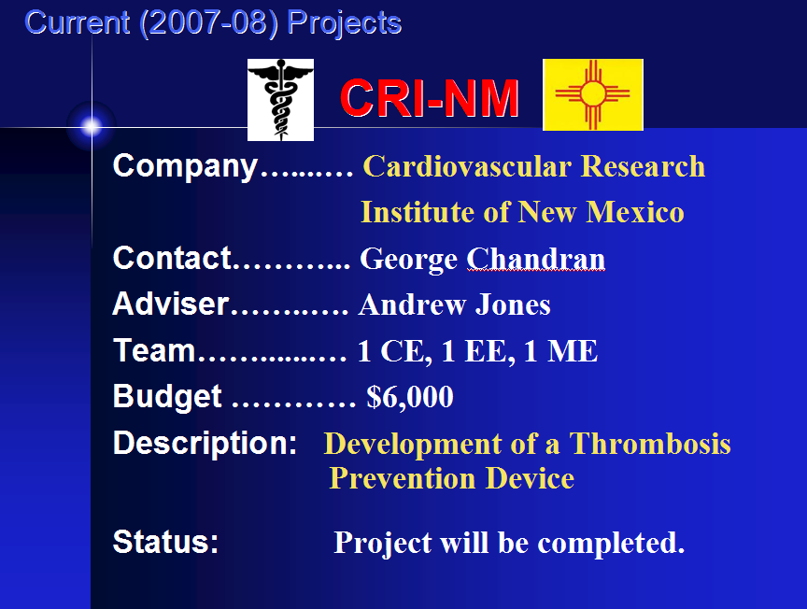

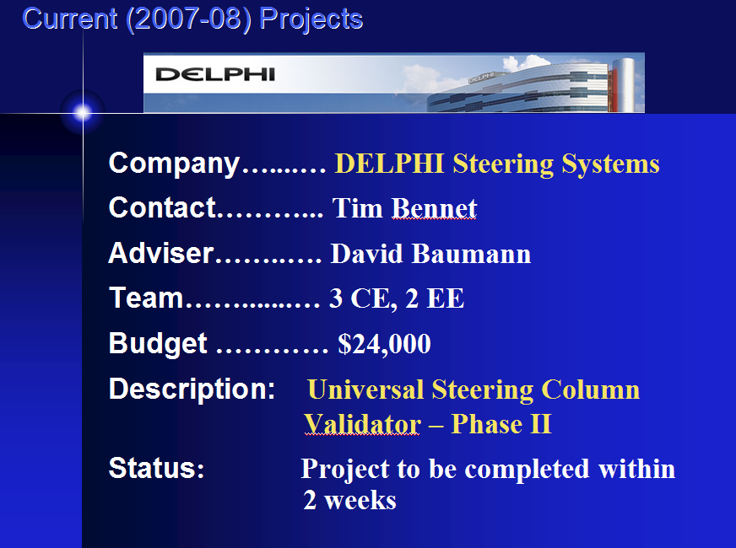

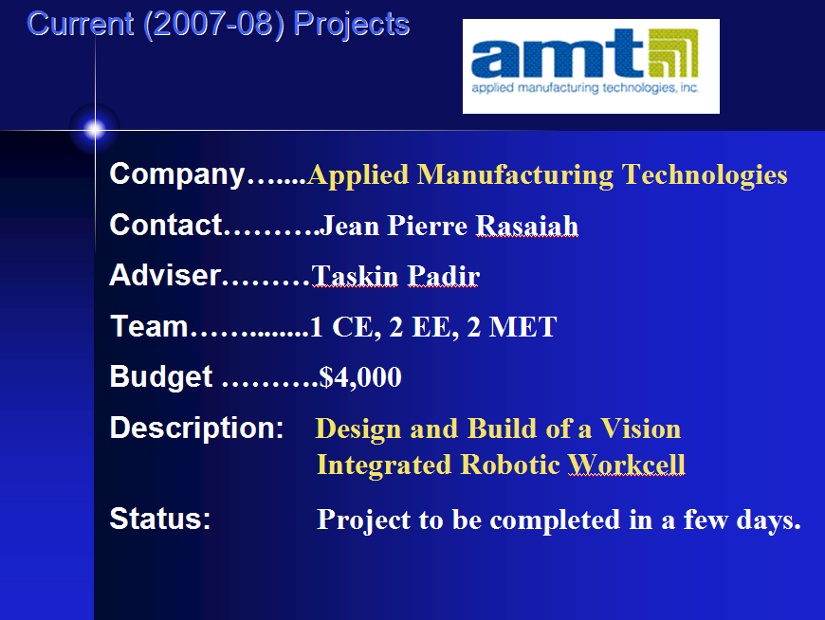

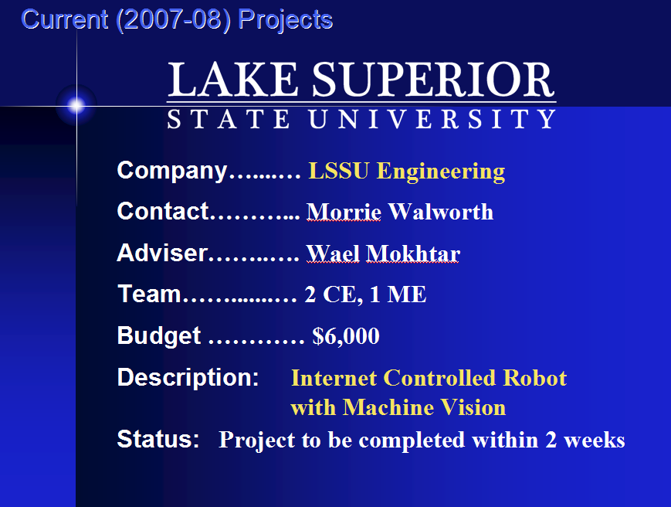

Presentations, Demonstrations and Schedules:
- Presentations
  - 1:00, 1:45, 2:30, 3:15, 4:00 in CASET 123
- Demonstrations
  - 1:45, 2:30, 3:15, 4:00, 4:45 in CASET
- SPFB solicits, values, and utilizes IAB evaluations of the presentations
- Evaluation forms – See attachments
- Provides “external evaluation” (ABET)
- Guidelines:
  - Look for ownership, professionalism
  - Technical competence via questions
  - Target audience is “grandmother”!
- Turn in at Video Camera - Don’t leave with the students!

Request for 2008-2009 Projects (See attachments)
Course Status:
- ~35 Students Expected For EGNR491
• 10 Electrical • 4 Computer
• 15 Mechanical
• 6 Manufacturing Tech
- Looking for 6 Projects
- Current Status – Interest From
• JR Automation
• LSSU – Mini-baja

Sponsor’s commitment
- Project Fee: $2500 + 5% of Budget
($3500 maximum)
- Provide Industrial Contact
- Responsibilities
• Sponsor to provide funding and special supplies
• LSSU to provide facilities and faculty advisor
• Students to design, construct, and manufacture (or research and prototype)
• Sponsor owns product

Project Selection Criteria – See attachments
- Match Between Students and Projects
- Match Between LSSU Resources and Projects
- Project Scope and Timeframe
- Clarity in Project Definition and Outcomes
- Evidence of Engineering and Financial Support

Submission of Project Proposals – See attachments
- Send by July 15th to Jim Devaprasad
- If you have any questions, call
(in this order):
1. Jim Devaprasad ……………. 906-635-2131
2. Morrie Walworth ………….. 906-635-2206
3. Paul Duesing …............……. 906-635-2137
- Please Submit Proposals!!!!

Summer Programs
- Women in Technology I (June 22-27)
- Robotics Camp I (July 6-11)
- Women in Technology II (July 13-18)
- Robotics & Technology Camp II (July 20-25)
- Robotics Camp for ATA (July 27- Aug 1)
- One of our best recruitment tools!
  - Typical Participant Profile:
    - Average GPA - 3.95
    - Average ACT Score - 25
    - Average # of Extra-Curricular Activities – 5

- Thanks To Past Supporters:
  - Perkins Grant (Women in Tech Program)
  - J C Huizenga Scholarships
  - Continental Automotive Systems
  - Chris Conklin and Dow
  - Charter Schools
- IAB Sponsorship Requested

A vote has taken place for the location of the next meeting.

Closing Remarks: Next meeting is planned for November 7, 2008 at Museum Bronze with Bob Andersen as one of the hosts.

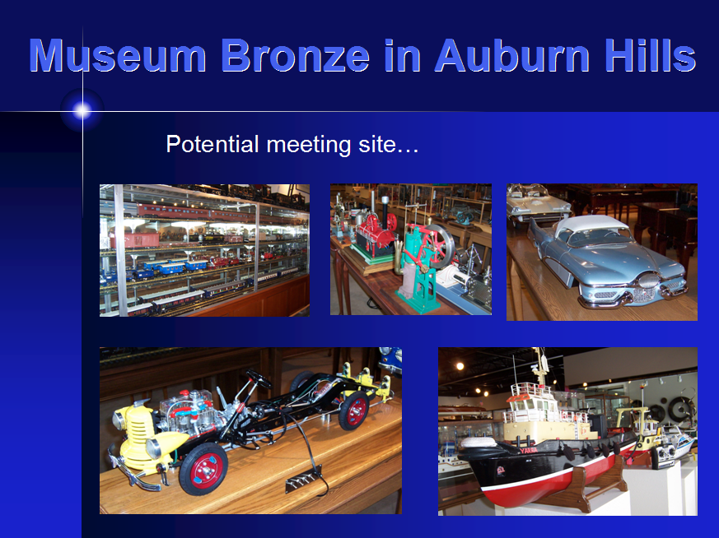
Action Items from May 2008 meeting: Responsible

New groups are needed for Early January time frame to host an open house. All Members

David McDonald is looking for some different parts that will interface with the All Members
CAN network. Please contact David if you have any ideas for him.

If anyone knows of any local trade shows that we can attend to represent LSSU, All Members
please let Chris know.

Attachments:
- Industrial-Based Senior Projects
- Project Selection Criteria / Project Proposal
- Project Submittal Form
- Senior Project Hand Outs
- Senior Projects Final Presentation IAB Evaluation Sheet

Respectively Submitted,
Lynnette Eding
LSSU IAB Secretary

