

**School of Engineering and Technology Industrial Advisory Board**

**Meeting minutes for May meeting at LSSU**

**Friday, May 1, 2009**

**Members Present:**

Bob Andersen, Fred Berg, Steve Bryan, Nathan Callaghan, Chris Conklin, Lynnette Eding, Jim Gibbs, Steven Kars, Ralph Larsen, Ralph Shoberg, Brian Theriault, John Truckey, Don Stephanic, Marty Zoener

**LSSU Personnel:**

David Baumann, Susan Camp, Eric Becks, Jim Deverpersad, Mansoon Janjua, David Leech, David McDonald, Wael Mokhtar, Jeanne Shibley, Morrie Walworth,

**Guests in attendance:**

Curt Reynolds

**Opening:**

Fred Berg opened the meeting and welcomed everyone to LSSU.

The previous meeting minutes were emailed to all members in addition to being posted on the LSSU website.

The action items from the November 2008 meeting were briefly reviewed:

**Action Items from November 2008 meeting: Responsible**

There was a suggestion to make up a kit or something that will catch the attention

of people when at these events. If anyone has any ideas, please contact Chris. All IAB members

What more can the IAB do to help LSSU? Morrie W/ Eric B

Eric could provide an update on what is happening at the PDC,

that would be great. Eric B

There needs to be a change to the IAB role statement to change the wording of

“Department of Engineering and Mathematics” to the “Department of Engineering

and Technology”. Fred B

The action items reviewed and minutes were accepted as stated for the November 2008 meeting.

All action items from the current meeting will be listed in RED in the meeting minutes below.

Chairmain’s Report –

* Fred Berg spoke of the state of the industry. Is there light at the end of the tunnel?
* Some IAB members on the move:

**Matt Witte** has left Chrysler and was technically a consultant as of  
 December 2008. He currently works at the University of Toledo as a  
 Research Engineer. Matt can be reached via email at: wit@TC3net.com.

**Dave Allison** from Dura has taken a position at Wayne Wire in  
 Kalkaska. Dave can be reached at: dallison@WayneWire.com.   
 Phone 231-258-0572

**Adam Lyon** from Dura has taken a position at Bio Fiber Solutions in Georgia  
 at: Phone: 706 -346- 9026. Adam’s email is: [adam.lyon@otrwheel.com](mailto:adam.lyon@otrwheel.com)

* Fred to work with Jim Gibbs to get the next meeting on Web X or GoTo meeting.

**Chairman’s Election:**

* Marty Zoener nominated Fred Berg to the Chairman’s position for another term.
* Ralph Shoberg seconded the motion.
* The motion passed by all in favor. Fred Berg is elected Chairman for another term.

**Subcommittee Updates:**

**Recruitment subcommittee-**

Chris Conklin, Jeanne Shibley, and other members of LSSU put together a Recruiting/Press Kit.

The purpose of the recruiting/press kit is to provide current information about the LSSU Engineering and Technology program to the Admissions counselors and IAB volunteers for the following efforts:

* Recruiting
* MACRAO Events
* Coffee table display on campus at the Admissions office for visitors.
* Engineering and Technology office display.

Recruiting/Press Kit Content/Sections:

* Section 1: Engineering and Technology Highlight Sheets.
* Section 2: Student organizations and competitions.
* Section 3: Senior Project brochures.
* Section 4: Pictures of Labs and Senior Projects.
* Section 5: Summer Camp Information
* Section 6: Mini CD
* Section 7: Employers and Graduate School listing.
* Section 8: Engineering and Technology Job Descriptions.
* Section 9: Alumni Section

The binders are a work in progress, but are planned to be finished for the first go around by August 21, 2009. They will be given to Susan Camp. They must be a living document and reviewed annually and updated as necessary.

Some additional ideas discusses for the binders:

* Add Financial Aid section
* Add activities outside of school section
* Add a list of unique LSSU things first things in the binder
* Add tabs separating the sections
* Add a summary page

Susan mentioned that Admissions had all the above mentioned items easily accessable.

**2009 Spring Macro Events**

* There was good IAB representation at the Spring 2009 MACRO events and positive feedback from all the events.
* The above mentioned Recruiting/Press Kits will be available for the 2009 MACRO events.
* THANK YOU to everyone who volunteered and participated in these events.

**Department of Engineering & Technology Updates**

**New Department Faculty**

* **Mansoor Janjua** 
  + Mechanical Engineering
  + New Jersey Inst. Tech.
  + Studied the complex physics of the self-assembly process of micron sized particles on electrified fluid-fluid interfaces!

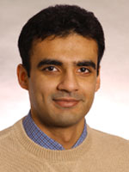

Enrollments:

* Admits are down (110/120).
* Freshmen enrollment begins in May
* Engineering specific: 1 less this fall and 3 more this spring



Recruitment and Retention

* **New initiatives with admissions**
  + Began this year
  + Early scholarship awards – All awards were out by March 1.
  + Automated mailings
* **IAB Involvement**
  + MACRAO Events – encourage new people to make the trip to campus for a tour.
  + Open Houses
  + Calling Students
    - Faculty Call First
    - Update Calling Sheets
* **Review of all Courses**
  + Low retention areas identified
  + New teaching methods explored
  + Focus on freshman year
* Add a recitation section for Sophmore/Junior classes – this will be some 1 on 1 time with faculty.
* Review results and report in the fall.

**Scholarships**

New Scholarships:

* Continued support from J.C. Huizenga
  + Summer camp scholarships
  + Freshmen scholarships
* Andersen Family Engineering Scholarship
  + Endowed
  + The purpose of this scholarship is to benefit a student(s) majoring in any engineering-related course of study at Lake Superior State University.



The calling campaign will be reinstated again this fall. It was cancelled in the spring.

**Awards**

**Student Competitions (ASME)**

2nd Place: Student Design Competition

* Mars Rover Design and Competition
* Qualified for National Competition

2nd Place: Old Guard Poster Competition

* Simulated Arterial Blockages for Ultrasound Training

4th Place: Old Guard Oral Presentation

* Pick-up Trucks and Aerodynamic Drag CFD Analysis

**Student Competitions (SAE)**

Mini Baja: Alabama (100 Competitors)

* 15th Place: Overall Dynamic Events
* 19th Place: Suspension & Traction
* 20th Place: Pulling
* 26th Place: Maneuverability

**Faculty:**

**Best Paper Award - 1st Place**

Paul Duesing and Wael Mokhtar

*An Effective Approach to Teach a Freshman Level CAD Course*

**As a Department**

**2 MIIE Grants** for Industrial/Economic Collaboration

**Designation as a SmartZone**

* Eric Becks, Jim Devaprasad, Valerie Filek, Jim Hendricks, and David Leach

**Program Updates:**

**Electrical and Computer Engineering  
--- CE Program Updates ---**

* EGNR-101 Intro to Engineering now in curriculum
* CSCI-201 Data Structures and Algorithms (3,0) or CSCI-221 Computer Networks (3,0)
* VLSI Design course and RTOS course on backburner and set to simmer

**Electrical and Computer Engineering  
--- EE Program Updates ---**

* None!

**Electrical and Computer Engineering  
--- EET Program Updates ---**

* Approved by Board of Trustees 20 hours ago!
* Retention
  + Catch CE and EE students struggling with math
* Recruitment
  + Attract freshmen interested in CE or EE who aren’t good in math
  + Attract freshmen interested in “computer” or “electrical” technology
* Can CET be far behind?
* **Electronic Manufacturing Processes (3,3)**
  + *schematics and circuit simulation (Cadence)*
  + *board design and lay-out (Eagle)*
  + *chip selection*
  + *surface-mount soldering techniques*
  + *programming pick-and-place machine*
  + *several “design-through-fabrication” projects*
  + *extensive experience with new PDC equipment*

**Electrical and Computer Engineering  
--- Open CE Faculty Position ---**

* Ph.D. EE/CE or M.S. EE/CE with experience
* Able to teach all of the following courses:
  + Digital Fundamentals (EGEE-125)
  + Digital Design (EGEE-320)
  + Assembly Language Programming (EGEE-250)
  + Embedded Microcontroller Systems (EGEE-355)
  + C Programming (EGNR-265)
* Able to teach at least one of the following courses:
  + Machine Vision (EGRS-430)
  + Robotics (EGRS-385)
  + Electronic Manufacturing Processes (EGET-310)

**Mechanical Engineering Updates**

Replacing: (EGEE 205) Analog and Digital Electronics

* General and Robotics Options

EGEE 280 Introduction to Signal Processing

or one of the 300 or 400 tech electives.

* Vehicle Option

EGEE 280 Introduction to Signal Processing.

Course Offerings:

|  |  |
| --- | --- |
| **Even years** | **Odd years** |
| **EGNR 310: Advanced Quality Engineering** | **EGMT 310: CNC Manufacturing Processes** |
| **EGME 425: Vibrations and Noise Control** | **EGME 415: Vehicle Dynamics** |
| **EGEE 365: Vehicle Instrumentation** |  |

**Manufacturing Engineering Technology**

**---Manufacturing Engineering Technology Updates---**

* Program Distinction – *Emphasis on Modern Technologies in Manufacturing*
  + Robotics
  + Solids Modeling and Animation
  + CNC and CAM
  + PLCs
  + Machine Vision
  + Manufacturing Simulation
* 2+2 Curriculum
* ABET Visit in Fall of 2010
* Manufacturing Trends – Considerations for the Future

**LSSU Prototype Development Center -**

**Capabilities**

* Design
* Rapid Prototype
* Electronics
* Microprocessor
* Testing/FEA
* Programming
* Documentation
* General Engineering Services
* Design Feasibility
* Finite Element Analysis
* Testing
* Tinius
* Rockwell
* Legal
* Service and Repair Manuals

**New Hardware**

* Ultrasonic Metal Flaw Detection
* Surface Mount Technology Assembly
* Laser Welder
* Subtractive R. P.

**New Software**

* Schematic Capture & Board Layout
* C Compiler
* Solidworks
* Pro – Engineer
* Delmia
* XnView , Viewmate, SVN, etc.

**General Software**

* MathCad
* MatLab
* Cadence
* IDEAS
* Delmia
* Delphi 6 (PASCAL)
* Borland C++
* LabView
* MS Project
* Pro-Engineer
* Studio 8
* Star (Fluids)
* Witness
* Acrobat 7 Professional
* Visio
* Car Sim.

**Projects**

* Surgical Tools
* Environmental Discharge Detection
* Post-op Complication Prevention
* Consumer Electronics - Proof of Concept
* Over-the-Counter Medical Device
* Solar Energy Projects
* Mechanical Separation of Undesirable Materials from Bulk
* Stationary Wildlife Sensing
* Industrial Fluid Quality Monitor (> 1 Year Data Storage)
* Sports Related Devices
* Various Mechanical Models
* Wireless Data Interface
* Bio-Diesel Conversion Equipment Redesign for Manufacture

**Industrial Clients**

* Bunker Manufacturing, Inc.
* Dataswitch (Minnesota)
* Cortech
* Delphi
* Energizer (Ohio / Nationwide)
* Precision Edge
* Western Engineered Products

**Institutional Clients**

* MSU
* U of M
* MTU
* LSSU

**Senior Projects Update**

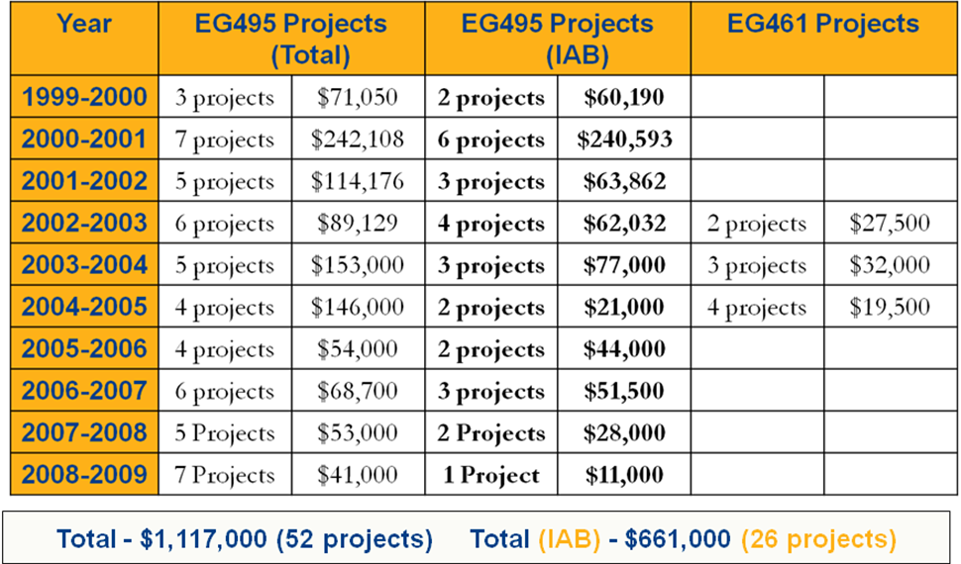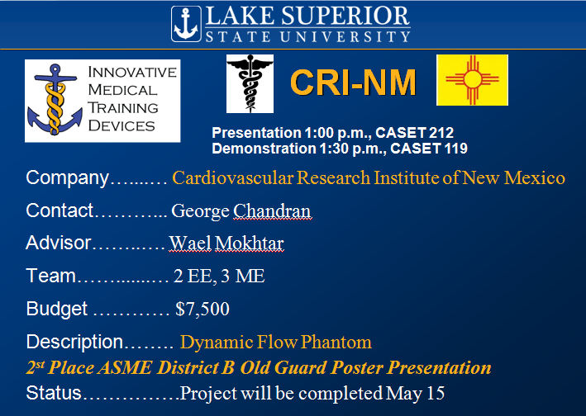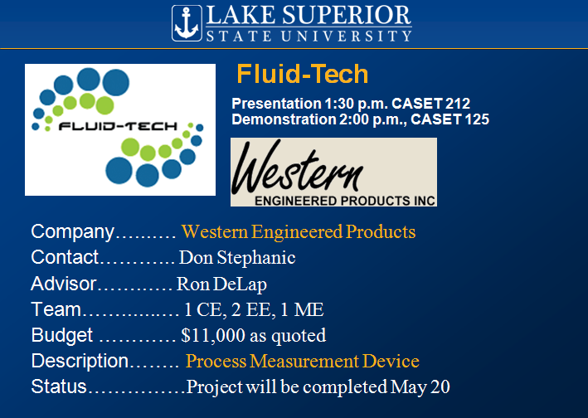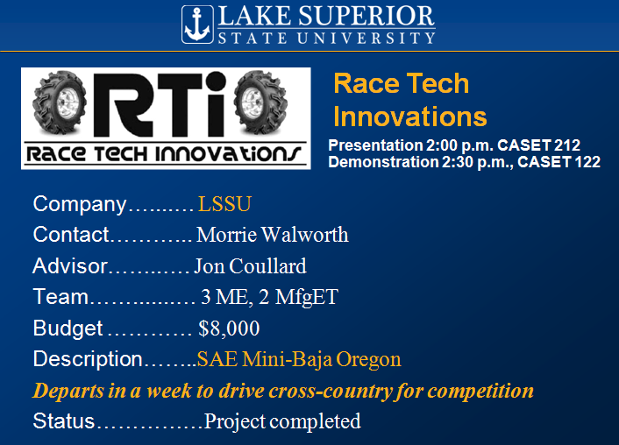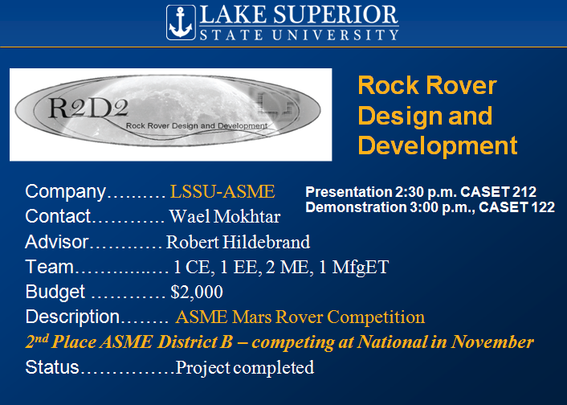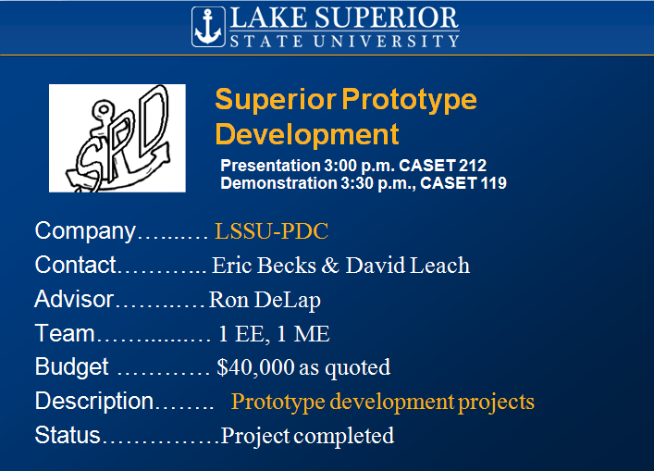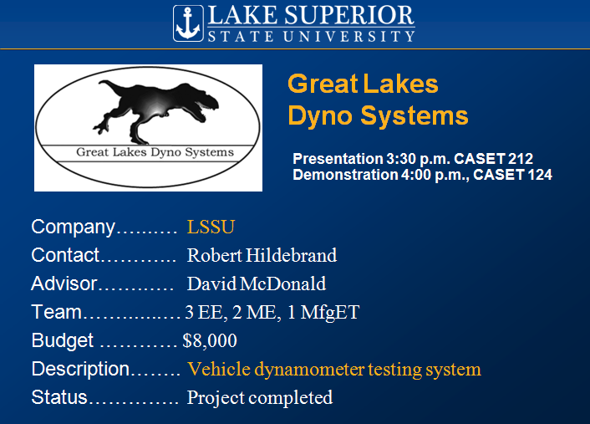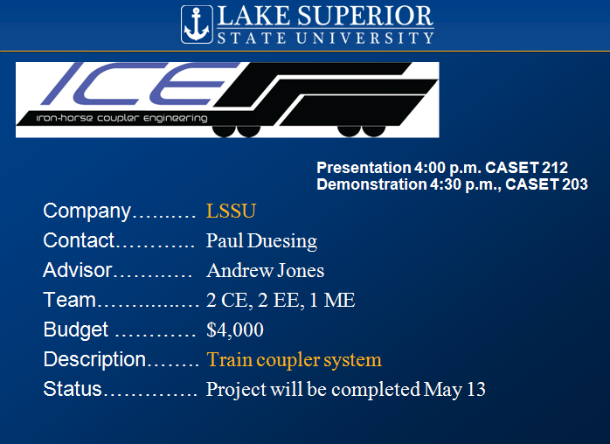

**2009 Senior Project Evaluations**

* Evaluation forms provided
* Provides “external evaluation” (ABET)
* Guidelines:
  + Look for ownership, professionalism
  + Technical competence via questions
  + Target audience is “grandmother”!
* **Turn in at Video Camera - *Don’t leave with the students!***

**2009-2010 Project Requests**

* ~31 Students Expected For EGNR491
  + 9 EE, 5 CE, 7 ME, 10 MfgET
* Looking for 6 Projects
* Current Status – Interest From
  + Revolutionary Engineering
  + LSSU – Mini-Baja?
  + PDC Projects
  + LSSU – Robotics

*No Other Inquiries*

* Match Between Students and Projects
* Match Between LSSU Resources and Projects
* Project Scope and Timeframe
* Clarity in Project Definition and Outcomes
* Evidence of Engineering and Financial Support

**REQUEST FOR 2008-2009 PROJECTS**Sponsor’s Commitment

* Project Fee: $2500 + 5% of Budget   
  ($3500 maximum)
* Provide Industrial Contact
* Responsibilities
  + Sponsor to provide funding and special supplies
  + LSSU to provide facilities and faculty advisor
  + Students to design, construct, and manufacture  
    *(or research and prototype)*
  + Sponsor owns product

**Summer Programs**

* Thanks To Past Supporters
  + Perkins Grant (Women in Tech Program)
  + J C Huizenga Scholarships
  + Continental Automotive Systems
  + Chris Conklin and Dow Corning
  + Charter Schools
* IAB Sponsorship Requested

**Closing Remarks**

* Next meeting is November 6, 2009 at Michigan Scientific

**Action Items from May 2009 meeting: Responsible**

* Fred to work with Jim Gibbs to get the next meeting on

Web X or GoTo meeting. Fred B.

* Prepare Recruitment/Press Kit for 2009 Macro events Chris C / Susan Camp

Respectively Submitted,

Lynnette Eding

LSSU IAB Secretary