Charter Schools Office

April 2017 ISSUE FROM THE TOP
Dear Academy Board Members and Leaders,
As we welcome in spring and look forward to summer, we at the Lake Superior State University Charter Schools Office would like to share with you some quick facts about our academies and programs. We have the honor of authorizing 22 academies with twenty seven sites throughout Michigan and serving over 9,500 students! We believe in investing in the students that we serve and offer both STEAM and Leadership Camps in the summer as well as other camps throughout the school year. LSSU CSO encourages you to reach out to Keith Krahnke, College and Career Readiness Coordinator at kkrahnke1@lssu.edu, to learn more about programs offered in Summer 2017. These are wonderful opportunities for students to visit our campus and learn more about a variety of topics. We are committed to supporting not only our charter school students but our charter school boards, administrators, teachers, parents, and students. Look throughout the year for opportunities for training in the areas of governance, compliance, finance, and academics. If you have any questions or would like to share a comment or concern with our office, please feel free to give us a call.
In closing, the week of May 1st-May 5th has been designated as National Charter School’s Week and May 3rd is Charter School Day at the Capital where hundreds of charter school supporters, including parents, educators, students, and community members gather in Lansing to celebrate the charter school movement. If you are interested in attending, please register at https://events.r20.constantcontact.com. I hope

to see you there!
Sincerely,
Chris Oshelski, Executive Director

-Accountability Update-
There is a saying in the Upper Peninsula of Michigan that “if you do no t like the weather wait ten minutes and it will change.” Apparently, the same can be said about the state accountability system in Michigan. I had attended the Michigan Institute for Educational Management’s (MIEM) 2017 Testing Conference on February 14th-16th in Ann Arbor. I eagerly attended Venessa Keesler’s presentation on “Assessment and Accountability in Michigan’s ESSA Plan.” Ms. Keesler outlined the proposed new accountability system and the “Top 10 in 10” years initiative that included adopting an A-F system. Imagine my surprise when I discovered that as of March 13, 2017, Michigan’s state Superintendent Whiston was dropping the plan to give a letter grade to every public school? Barring legislative action, Michigan will instead issue a dashboard of sorts with no grades. The A-F system was intended to assist Michigan in becoming a top-10 state in education. There has been much debate on adopting the letter grade system which would be comprised of one overall letter grade for schools as well as individual letter grades for seven indicators. The seven indicators include; student growth, proficiency, graduation rate, English Learner Progress, Participation in state assessments, School Quality/Student Success, and English Learner Participation in WIDA assessment. Michigan’s default plan is to offer a “dashboard” of sorts with no grades unless legislators vote to switch to the A-F system. MAPSA’s president, Dan Quisenberry, stated, “we grade students, why not schools?” Look for further information in July. Submitted by Julie Hopper, Academic Assessment Specialist

IMPORTANT DATES

2017-2018 Testing Windows
- Fall: Sept. 5– Sept. 29, 2017
- Winter: Jan. 15-Feb.9, 2018
- Spring: Apr. 2-Jun. 1, 2018

NOTE: If you are in need of a testing window modification, please send your requests to Julie Hopper, Academic Assessment Specialist, at jhopper@lssu.edu at least 2 weeks prior to the beginning of the designated testing window start date.
Academies are required by contract to assess students three times per year during the given testing cycles. This allows us to track important growth data.
LSSU Charter Schools
650 W. Easterday Avenue
Sault Ste. Marie, MI 49783

906-635-2121

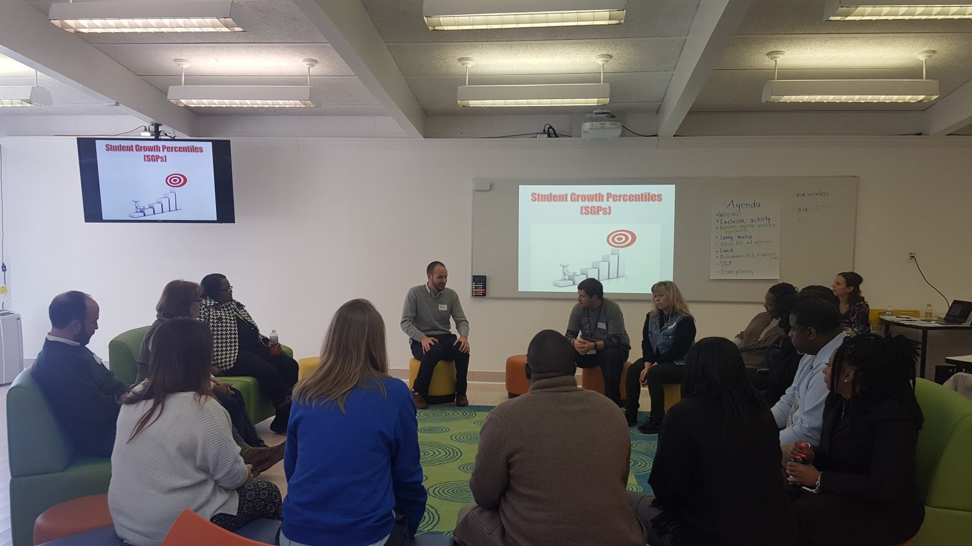
COMPLIANCE CORNER
Important Dates to Remember:
• Board training will be held on the following dates and places and cover such topics as; purpose of governance, board fiduciary duties, board policy, board challenges, input principles and output results.
- May 24– @ Grand Traverse Academy
- June 5- @ DSLA-Redford site
Please look for an invitation from Jenny Peterman.
FINANCE UPDATE
Important Dates to Remember:
- May 15, 2017– 3rd Quarter Financial Statements task due in Epicenter
- May 31, 2017– Budget Timeline for 2017-18 due in Epicenter
- June 20, 2017– Public Hearing Notice for
2017-18 due in Epicenter
- June 30, 2017- Adopted Budget Resolution 2017-18 Budget task due in Epicenter
- June 30, 2017- Budget Revision Resolution
2016-17 task due in Epicenter
- June 30, 2017- Year End for 2016-17 fiscal year...Another year in the books!
Items to Consider:
Finances can be scary, confusing and intimidating,
but we are here to help! Please contact the CSO Finance Specialist, Becky Clawson, at 906-635-2279 or rclawson@lssu.edu if you have any questions or just want to talk about your Academy's finances!
Please let Becky know if you have any suggestions for future finance topics!
FROM THE FIELD
Important Dates to Remember:
• Spring sites are currently being conducted.
A shout out to Detroit Service Learning Academy. At the beginning of March, the Detroit area experienced a high wind storm that knocked power out to 800,000 homes and businesses. The security and maintenance workers at DSLA were not willing to let their building in Detroit sit in the dark with no alarm, lights, or heat and open for possible looters and vandals. These dedicated workers spent the next four days and nights in the building to keep vigil over it. When electricity was restored at midnight on Sunday, crews showed up at 3 a.m. to prep the building for the return of students on Monday morning. Thank you to all security and maintenance personal at DSLA for going well above and beyond your call of duty out of love for your position and students.
*Submitted by Melissa Weisberger, Field Consultant
The Michigan Association of Public School Academies (MAPSA) has named the semi-finalists for the 2017 Michigan School Teacher and Administrator of the Year. There are more than 10,000 charter school teachers and more than 1,500 charter school administrators in Michigan. MAPSA confirmed that nearly a thousand nominations were received for this year’s awards. A panel comprised of judges narrowed down the semi-finalist list to twenty five teachers and ten administrators. During the week of March 27, the semi-finalist list was narrowed down further to only five for each award with the five finalists being invited to Lansing to be honored and featured on MAPSA’s Facebook page. The overall winners for each award will be announced during National Charter Schools Week in early May. LSSU Charter Schools Office is proud to announce that we had two teachers from academies authorized by LSSU be included in the twenty five semi-finalists for teacher of the year. Lindsay Haycock, Advanced Technology Academy in Dearborn and Cinda Shumaker, Concord Academy Boyne in Boyne City. Way to go Ladies!

We’d also like to congratulate, Ms. Monseratt Navarro, former student from Advanced Technolo-
gy Academy, who was selected as “Freshman Female of the Year” at Lake Superior State University for 2016-2017. We are so very proud of your accomplishment!
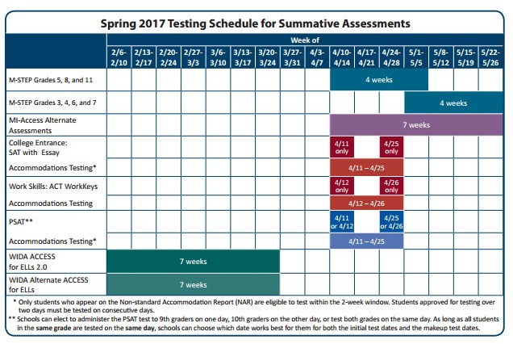
Staff from selected academies attended the Step N’ Up Workshop that was held at American International Academy in Westland, MI on March 15th, 2017. The Institute for Excellence in Education presented training focused on exploring, analyzing, identifying strategies, and developing plans for MSTEP preparation. Thank you to Superintendent, Mr. Tom White, for hosting the event. Attendees learned valuable tips for preparing students for the upcoming state assessment. Lake Superior State University Charter Schools Office is currently planning a Professional Development Calendar for the 2017-2018 school year. More information to come. Good luck to all academies.
Newsworthy

