Charter Schools Office

January 2017 ISSUE FROM THE TOP
Dear Academy Board Members and Leaders,
Happy New Year! I hope you found time to relax and rejuvenate over the holiday season and are ready to begin 2017. January is designated as School Board Member Recognition month. Thank you for serving on the board for an academy authorized by Lake Superior State University and for the countless hours you have vested in bettering the educational opportunities for Michigan students. Your contribution to your academy is greatly appreciated.
We have decided to launch a new venture and are proud to present our first edition of the Lake Superior State University Charter Schools Office newsletter. We will publish the newsletter quarterly (September, January, April, July) and it will notify you of any upcoming deadlines, contain important information or notifications at the state or authorizer level, as well as other pertinent topics. We are also planning on featuring our academies and the unique learning opportunities for students that attend academies authorized by LSSU. If you would like to have your academy featured in one of our newsletters, please contact Julie Hopper at jhopper@lssu.edu or 906-635-2118. We look forward to hearing your stories!

Sincerely,
Chris Oshelski, Executive Director

-Accountability Update-
The Michigan Department of Education (MDE) released the highly anticipated state’s score cards on Friday, January 20th, 2017. We are told that this is the last time the MDE will use the color-coded score cards and Top to Bottom list as the MDE is developing a new accountability system in compliance with the new federal law, Every Student Succeeds Act or ESSA. State Superintendent, Brian Whiston commented “with the continued improvement to our state assessment system, we promise to still be transparent and hold schools accountable to student achievement.” He continued “these score cards are a good diagnostic tool for local schools to drive improvement and instruction.” The MDE will not be labeling schools as Priority or Focus Schools this year, however, over 200 Reward schools were identified. Reward schools are identified by meeting the following criteria; Earning a scorecard color other than red and either in the Top 5% of schools on the TTB list, in the Top 5% of schools making the greatest gains in achievement, or were a Beating the Odds school by outperforming their schools predicted ranking. Also, noteworthy is that 89 schools earned their way off of their Focus school status by having above average improvement or achievement by the lowest performing 30% of their students when compared to statewide averages for students in this category.
Scorecards and Top to Bottom Rankings for individual academies can be viewed at https:// www.mischooldata.org/.
The 2015-16 Top to Bottom list can be found at http://www.michigan.gov/documents/ mde/2015-16_Accountability_Results_List_for_Print_549027_7.pdf

IMPORTANT
- NWEA/PST Winter Testing
January 16-February 10
- MIEM Testing Conference in Ann Arbor on February 14-16
- MAPSA’s Innovators in Education
Conference in Lansing on March
14
- MSTEP Testing Window
April 10-May 26
*check specific dates by grade level
- PSAT/SAT/Work Keys/MSTEP
Science/Social Studies 11th
April 11, 12
- NWEA/PST Spring Testing April 10-May 26 with June 2nd
makeup
http://www.michigan.gov/documents/mde/ Spring_2017_Guide_to_State_Assessments_ jl_536062_7.pdf
LSSU Charter Schools
650 W. Easterday Avenue
Sault Ste. Marie, MI

49783

COMPLIANCE CORNER
Important Dates to Remember:
- Board member appointment/reappoint-
ment applications and other supporting documents must be received by April 4th for terms that expire June 30, 2017.
- MDE notification of new or expanding
charter schools (including new sites, changing grade levels and additional enrollment of 50+) will be due by April 4th. Look for additional information in March. • Board trainings will be offered this summer.
Look for additional information to come.
FINANCE UPDATE
Important Dates to Remember: • Feb. 8 (2nd Wednesday in Feb.) Count Day!
The Count is still 90/10 and your state aid payment should be updated to reflect the blend by the March payment
- Feb. 15– 2nd Quarter Financial Statements–
Balance Sheet, Income Statement & Budget to Actual
- Mar. 31– Amended Budget Resolution
Submit any Amendment between Jan. 1 and Mar. 31
- Mar. 31– Financial Audit Letter Engagement Things to Consider:
Conflicts of Interest & the appearance of a conflict
of interest - be aware of any potential conflicts and how to avoid and/or disclose them.
Finances can be scary, confusing and intimidating, but we are here to help! Please contact the CSO Finance Specialist, Becky Clawson, at 906-6352279 or rclawson@lssu.edu if you have any questions or just want to talk about your Academy's finances! Also, please let Becky know if you have any suggestions for future finance topics!
FROM THE FIELD
Important Dates to Remember:
• April 4- Please remember that applications for board reappointment are due by April 4 , 2017. Please contact your field representative if you have any questions

January is designated as School Board Member Recognition Month. We would like to thank all of the board members serving on the board for an academy authorized by Lake Superior State University. We appreciate your commitment to our students in ensuring they receive a quality education. Thank you for all that you do. Please contact the field representative at any time if you have any questions, comments, or concerns.
Actions Required | Timeline
All “Combined Reports” are available for preview but are embargoed | Beginning January 20, 2017
Districts and schools finalize AER cover letters | January 20-29, 2017
First date “Combined Reports” and cover letters may be posted for public review | January 30, 2017
Date for all districts and schools to post final  “Combined Reports” and cover letters | March 13, 2017
We wanted to take a moment to congratulate Bay City Academy on a job well done! Bay
City Academy had three locations for the 2015-16 school year; Bay City Farragut, Bay City Madison, and North Central Academy. Bay City Academy is founded on Dr. William Glasser's Choice Theory. Choice Theory explains that almost all human behavior is chosen and that we are driven by our needs for survival, love and belonging, power, freedom and fun — the most important of which is love and belonging. Students learn the Seven Caring Habits of supporting, encouraging, listening, accepting, trusting, respecting and negotiating differences. Bay City has made some amazing strides. In 2013-14, Bay City Madison was identified as being a Priority School. With intentional interventions, Bay City Madison moved from a ranking of zero in 2013-14 to a ranking of 39th in 2015-16. North Central Academy moved from the 13th percentile in 2013-14 to the 77th percentile in 2015-16. Bay City Farragut received a percentile ranking of 83rd in 2015-16.
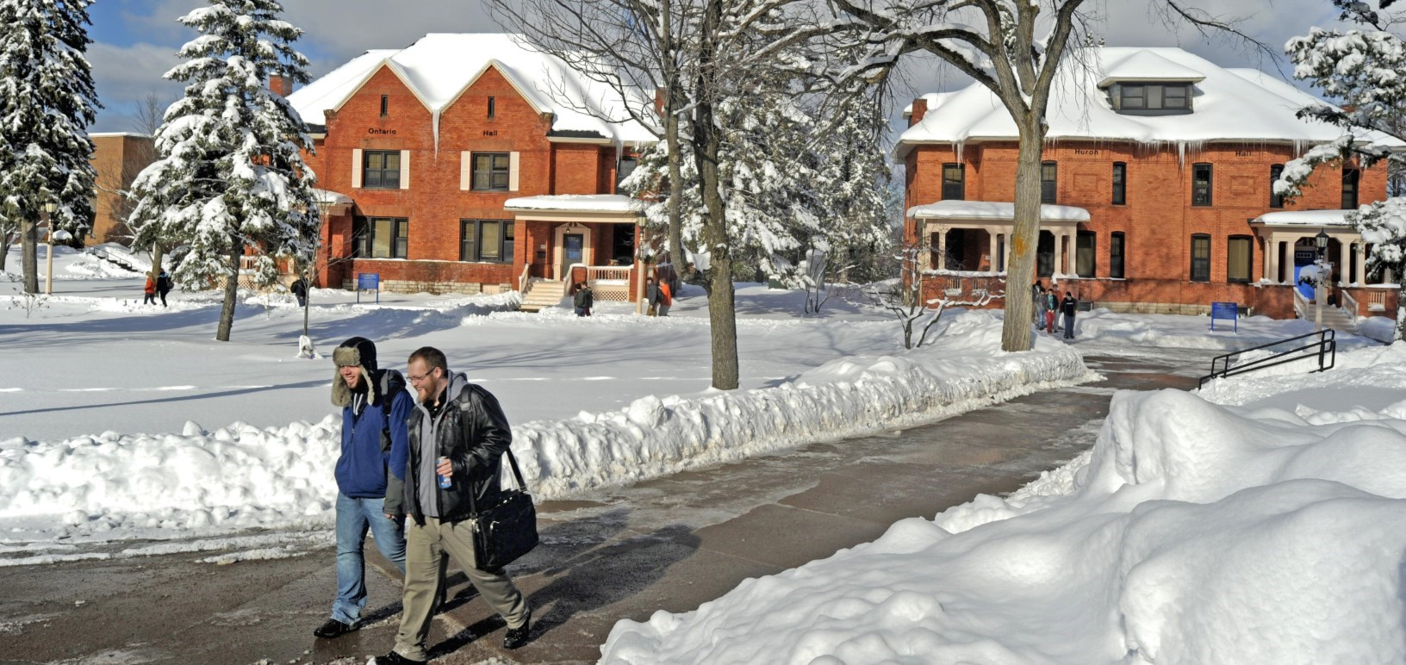
Annual Education Report
The MDE typically requires districts and schools to communicate their Annual Education Reports to communities and parents in August of each year to fulfill requirements under the Elementary and Secondary Education Act (ESSA). Due to a new assessment and accountability system, AER’s have been delayed until now. The new timeline for meeting the 2016-17 AER requirements are as follows:
The AER is designed to meet the federal requirements of ESSA of 2001 for an annual report. The Combined Report provides detailed data on state administered student assessment results, accountability results, teacher qualification information, and the state results for the National Assessment of Educational Progress (NAEP). There is a “Combined Report” populated with the appropriate information for the state, each LEA, and each school. If used as designed, the “Combined Reports” and cover letters also meet the state requirements for reporting to parents and communities in an annual education report. For more information as well as , please visit the following link. http://www.michigan.gov/documents/mde/AER_FAQ_549198_7.pdf
Newsworthy

