Charter Schools Office

July 2017 ISSUE FROM THE TOP
Dear Academy Board Members and Leaders,
I hope you and your families are having an enjoyable summer. It certainly is a beautiful time of year in the Upper Peninsula. If you have not yet made the trip to the “U.P.” during the summer months, I encourage you to do so. We are well known for providing the perfect outdoor venue for a variety of activities for nature lovers including camping, swimming, boating, fishing, hiking, golfing and much more. Make sure to stop by our office and say hello if you are in the area.
As an authorizer, we are constantly striving to improve our support and oversight for the academies we authorize. Looking ahead to the 2017-18 school year, we will focus on providing more professional development opportunities for academy administrators and teachers as well as board training opportunities. We will also continue to offer our compliance grant for academies that exhibit accurate and timely submissions into Epicenter as well as continue our summer camp and on site learning opportunities for our students that attend LSSU academies.
LSSU CSO prides itself in making ourselves available to academies to answer any questions. Although we must hold you accountable to meet your contractual obligations, we consider ourselves your partners in education and want to do everything we can to assist you in providing a quality education to the students that attend your academy. As always, do not hesitate to contact me if I can be of assistance.

Sincerely,
Chris Oshelski, Executive Director

-Accountability Update-
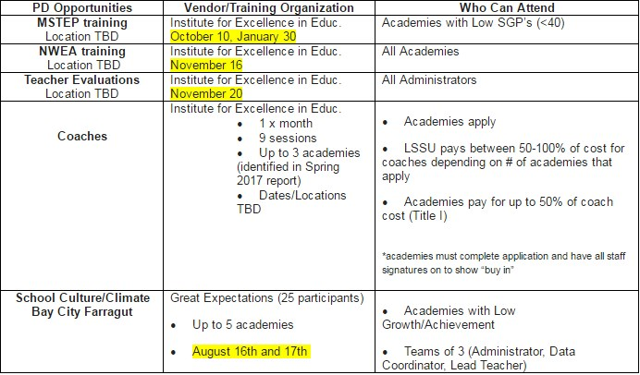
Lake Superior State University Charter Schools Office will implement a new system of support for 2017-18 that is based on an academy’s student achievement and growth data from 201617. Academies will qualify for support depending on where they fall in our Quadrant System. Quadrant I academies exhibit both high growth and high cohort achievement, Quadrant II academies exhibit high growth and low cohort achievement, Quadrant III academies exhibit both low growth and low cohort achievement , while Quadrant IV academies exhibit low growth but high cohort achievement. We will offer a variety of professional development in 2017-18; MSTEP training, NWEA training, training on Teacher Evaluations, and School Culture and Climate. All academies qualify for the NWEA and Teacher Evaluation training while MSTEP, School Culture/Climate, and Coaching support will be focused on those academies with “Priority Status” designation meaning those that fall into Quadrant III or our system. Your academy will be notified if they qualify for support once the 2016-17 annual reports are distributed. Please contact me if you have questions. Julie Hopper

IMPORTANT DATES

2017-2018 Testing Windows
- Fall: Sept. 5– Sept. 29, 2017
- Winter: Jan. 15-Feb.9, 2018
- Spring: Apr. 2-Jun. 1, 2018

NOTE: If you are in need of a testing window modification, please send your requests to Julie Hopper, Academic Assessment Specialist, at jhopper@lssu.edu at least 2 weeks prior to the beginning of the designated testing window start date.
Academies are required by contract to assess students three times per year during the given testing cycles. This allows us to track important growth data.
LSSU Charter Schools
650 W. Easterday Avenue
Sault Ste. Marie, MI 49783

906-635-2121

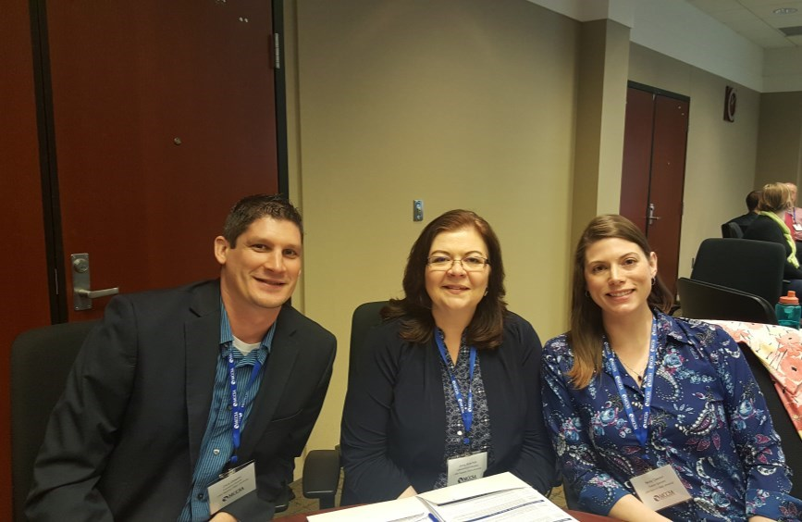
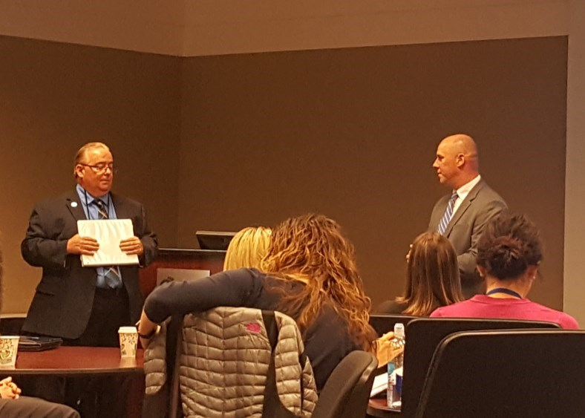
Lake Superior State University Charter Schools Staff attended the first annual Michigan Authorizer Confer-
ence on May 2nd in Lansing, Michigan. State Superintendent of Education, Brian Whiston, was the keynote
speaker. Superintendent Whiston commented on a focused effort for post
-
secondary opportunities for stu-
dents, establishing a connection with the business community, and building multiple pathways for students.
Conference attendees had the opportunity to attend workshops on a variety of topics including; legal updates
impacting charter schools, accountability changes, fiscal oversight, authorizing, and establishing positive board
relationships.

COMPLIANCE CORNER

Important Dates to Remember:

•

Compliance grant award notifications will be
sent out by mid August

◻

Academy and ESP insurance policies are to
be sent to Hylant for review by July 31st

◻

Please provide board and school calendars
for 2017
-
18
to CSO

◻

Please notify the CSO of any Academy
Leadership changes ASAP

FINANCE UPDATE

Important Dates to Remember:

•

July 28, 2017
–

4
th Quarter Financial State
-
ments task due in Epicenter

Note: Finances can be scary, confusing and intimi-
dating, but we are here to help! Please contact the
CSO Finance Specialist, Becky Clawson, at 906
-
635
-
2279
or rclawson@lssu.edu if you have any ques
-
tions or just want to talk about your Academy's
finances!

-
Newsworthy
-

-
SPOTLIGHT
-

Left
–

MCCSA, Executive Director, Jared Burkhardt acknowl-
edges Superintendent Whiston at the MCCSA conference.

Right
-

LSSU CSO staff attend MCCSA conference
–

Left to
(
Right) Executive Director, Chris Oshelski, Jenny Peterman,
and Becky Clawson.

Detroit Service Learning

A shout out to Detroit Service Learning Academy on a successful “Ties
and Tiara’s Daddy/Daughter” dance. DSLA Superintendent, Shannon
Smith said that it was an overwhelming success with over seven hun-
dred fathers and daughters attending. Refreshments were served and a
good time had by all.

Advanced Technology Academy

Congratulations to
Claddis Stoner
of Advanced Technology Academy
who was recognized by WXYZ’s as one of Detroit’s “Brightest and Best”
high school graduates of 2017. WXYZ has honored high achieving
students for thirty eight years by inviting them to the station to meet
the news team as well as network with one another. Students are
chosen by their schools to attend with 200 schools participating.
Stoner is dual enrolled in Henry Ford College and plans on applying to
Carnegie Mellon University where she is interested in studying com-
puter science with a specialization in artificial intelligence. She has
clocked an impressive 530 volunteer hours and loves to help others.
Her advice, “don’t let anyone set what you can/cannot do...so many
people told me I do too much but I was till on the top...you can do it!”
We believe you will do great things, Ms. Stoner.

We’d also like to recognize,
Michelle Peres,
a 10th grader from
Ad-
vance Technoology Academy
, who won second place in the National
Charter Schools Institute’s Annual Essay Contest. The theme of the
essay contest was, “Prepared to Succeed in Life.” Nicely done!

Miss Claddis Stoner
Advanced Technology Academy
WXYZ’s Brightest and Best Recipient

NEW Requirement

With the passage of HB 4822 a.k.a. the “3rd
Grade Reading Law,” beginning in 2017
-
18
,
academies will be required to assess K
-
3
rd
graders in reading by a state approved assess-
ments. Students that are deficient must be
given an Individual Reading Improvement
Plan and parents must be notified of their
child’s deficiency and plan of action. For
more information, go to https://mea.org/
learn
-
whats
-
in
-
the
-
new
-
third
-
grade
-
reading
-
law/

