HLC Peer Reviewer Site Visit for Institutional Reaccreditation
http://www.lssu.edu/hlc/
http://hlcommission.org/Criteria-Eligibility-and-Candidacy/criteria-and-core-components.html
MISSION Our mission at Lake Superior State University is to help students develop their full potential. We launch students on paths to rewarding careers and productive, satisfying lives. We serve the regional, state, national and global communities by contributing to the growth, dissemination, and application of knowledge.

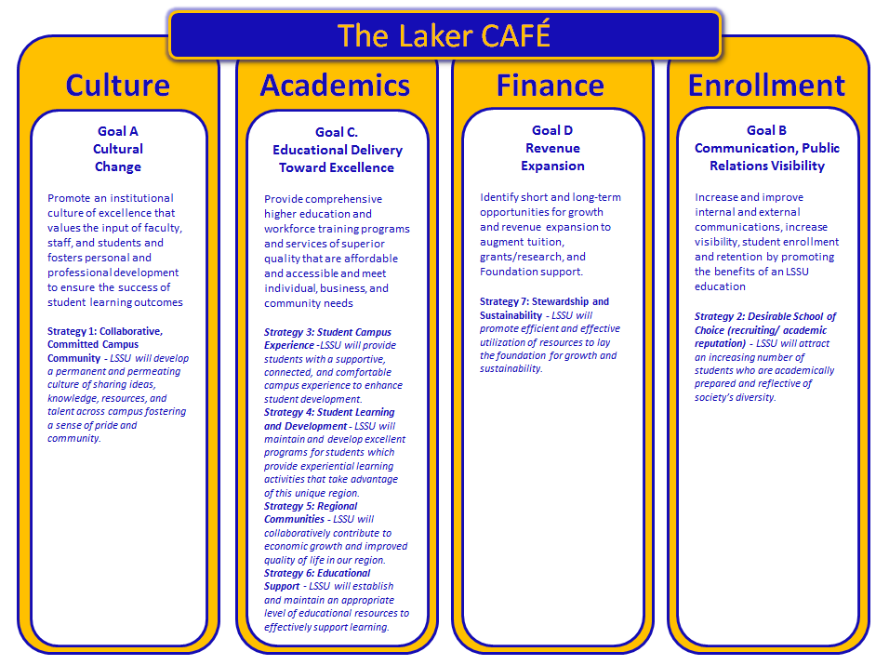

Core Values
- Excellence in Teaching and Learning. Teaching is our first priority and focuses on providing student/faculty interaction, learning, and research in current, relevant programs.
- Opportunity. Students have a wide range of opportunities to grow academically, professionally, culturally and socially. Opportunities are provided via work-study assignments, student organizations, internships, community outreach and leadership.
- Diversity. Students experience a campus community environment which is inclusive and welcoming.
- Ethics and Values. The University promotes an environment which values honesty, openness, and courteous behavior where everyone is treated with respect.
- Stewardship. LSSU provides a framework in which to leave the university and region financially and environmentally sound for future generations of LSSU students, alumni, and friends.

LSSU Vision Statement
Our programs grow and evolve in ways that keep our graduates at the cutting edge of technological and societal advances. As such, we will be viewed by our constituents as:
- The preferred regional choice for students who seek a quality education which provides a competitive edge in an evolving job market.
- An institution where relevant concepts are taught by quality faculty, and are paired with practical real-world experience to provide a well-rounded education.
- An institution which capitalizes on its location to instill graduates with an understanding of environmental issues and an overarching desire to be responsible stewards of the environment.
- A University that is highly student centered and empowers all students to realize their highest individual potential.

Sample questions for everyone:
- How is the university mission suited to the nature and culture of the institution?
- How does the institution ensure that planning and budgeting priorities align with the mission?
- How was the decision to pursue and then implement the Title III grant linked to assessment of institutional needs and fulfillment of the mission?
- Neither the mission or vision statement have reference to diversity, a key element of Criterion 1.C. How does the institution address its role in a multicultural society?
- The institution recently went through another reorganization, and conducted a series of layoffs, non-renewals; and denial of tenure for faculty late in their promotion/tenure cycle. How do these actions reflect on the commitment to operating with integrity, and demonstrate the fair and ethical behavior of administration?
- Identify examples of where the board has delegated management of the institution to administration; and where faculty exercise appropriate oversight of academic matters?
- What institutional policies and procedures reflect the University commitment to freedom of expression and the pursuit of truth in teaching and learning? (It’s not explicit in the mission, vision, core values, or faculty agreement)
- How does the University ensure that program quality and learning goals are consistently met at the regional centers, at our dual enrollment sites, and online? What kinds of evidence do we collect and how have we used that information to make changes?
- The general education program is a traditional distributional series of introductory courses, how does the University assess achievement of institutional outcomes at graduation?
- The General Education Committee has prepared annual summaries by outcome, but these reports are spotty at best, and totally absent for key outcomes like communication. This year the university discontinued the ETS Proficiency Profile testing. How is the University ensuring that students are meeting the intended outcomes of the general education requirements?
- What is the process the University will use to ensure that all instructors are appropriately qualified, especially in the context of the September 1, 2017 implementation date? How have faculty been involved in the development of these policies and procedures?
- Describe the promotion and tenure process and how the process has changed since the last visit and monitoring report. What is the role of the University Advisory Committee on Promotion and Tenure.
- What professional development opportunities are provided to student support services staff? How does the university ensure staff are appropriately qualified, trained and supported?
- The University recently restructured the Academic Support Services area and reduced the Career Services area. What evidence is the University collecting and how is it using that information to ensure we meet the needs of our student population
- Do what extend does the university provide student support services to students online, at regional centers, and those enrolled in dual-enrollment programs?
- Describe examples of the assessment of co-curricular programs, and how that information supports our claims to provide an enriched education environment at the University?
- The university appears to have nearly 100 academic programs, but has conducted program reviews of only 35 or so in the past 5 years. How does the University demonstrate responsibility for the quality of its educational programs without doing some level of program review?
- How does the University ensure that students in dual-enrollment programs are achieving equivalent learning and achievement of the course-level student learning outcomes? What evidence have we collected on comparative performance and how have we used that information to make changes?
- How does the University evaluate the success of its graduates – what institutional indicators do we deem appropriate to gauge that success and what evidence we do we have that graduates are well prepared for advanced study or employment?
- The University recently completed their commitment to the HLC Academy for the Assessment of Student Learning, and made strong gains in the areas of course and program assessment. How will this momentum be continued, and what role will an assessment committee play in the new shared governance structure?
- At the time of the academy project less than 60% of courses taught in the past five years had gathered information on student learning and defined actions to use that information. Less than 40% of academic programs had done the same. How does the University intend to demonstrate its commitment to education achievement and improvement through the ongoing assessment of student learning?
- What are the institutional goals for student retention, persistence, and completion? Did we meet our goals last year, in each of the last 5 years? How were these goals set and why do we believe they are attainable and appropriate to our mission?
- The university reported a balanced budget for this year but a substantial general fund deficit. What leads the University to believe that it has the fiscal and human resources to support its operations
- Describe the institutional process for budgeting and monitoring expense?
- How were faculty and staff engaged in the process of establishing the cuts needed to reach a balanced budget for this year, and how was this different that previous years which led to the structural deficit?
- How does the new shared governance structure reflect a collaborative process for decision making? Describe faculty involvement in the changes to shared governance this past summer.
- How does the University link its processes for: assessment of student learning, operational evaluation, planning and budgeting. What examples or evidence do we have of this linkage?
- How has the university worked over the past five years to develop and document evidence of performance in its operations. What key performance indicators does it use to evaluate performance? Give examples of how it has used this information to improve effectiveness.
- Describe the transition from the balanced scorecard approach to the strategic plan assessment to the current CAFÉ goals. How is the university positioned to assess achievement of the four goals?
- Declining enrollment and reduced state support impact many small public universities. How has the University engaged in systematic and integrated planning, and worked systematically to improve performance? How does the university collect evidence of performance across operational units and align that information with the university mission and/or goals?
http://hlcommission.org/Criteria-Eligibility-and-Candidacy/criteria-and-core-components.html
Questions: contact David Myton, Ph.D. Associate Provost, Lake Superior State University

