Charter Schools Office

September 2017 ISSUE FROM THE TOP
Dear Academy Board Members and Leaders, Welcome Back!
I hope you all had a fun filled summer that included quality time with loved ones. My family was busy with baseball games and completing renovations on our house but we were still able to check a few things off of our “bucket list.”
The start of a new school year lends one to reflect on years passed. The 2017-18 school year marks my third year as Director of Lake Superior State University Charter Schools Office. It has been an interesting journey with much learned along the way. I feel good about the direction in which we are headed; providing more support services to our academies. We believe that our success as an authorizer is measured by the success of each of our academies.
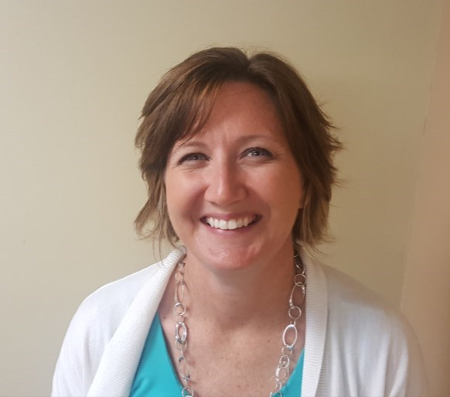
Our new president at LSSU, Dr. Peter Mitchell, recently kicked off the year with convocation. In his address, he introduced me to a new word,“autopoiesis.” Autopoiesis is “the characteristic of living systems and organizations to adapt to a constantly changing environment by continuously renewing themselves and regulating processes so that the integrity of their structure and purpose is maintained.” It struck me that in the charter school world, we are constantly adapting and renewing ourselves to better meet the needs of the students we serve. As an authorizer, we undergo “autopoiesis” adapting to better serve you, our academies, yet keeping the same mission in mind...to ensure that the students that attend our academies receive a quality education that leaves them college and/or career ready. We look forward to the challenge of a fresh year and are here to help you have your best year yet. Please do not hesitate to contact any of us at Lake Superior State University Charter Schools Office if we can be of service to you. Call to ask a question, for clarification, or to just chat.

Looking forward to our conversation.
Sincerely,
Chris Oshelski, Executive Director

-Meet Your School Support Specialist-

We are very pleased to announce the addition of Brooke Maciag to our charter school team. Brooke will serve as our School Support Specialist. The School Support Specialist will work with our academies to improve student growth and cohort student achievement. Brooke comes to us from DeTour Arts and Technology Academy where she held roles as Principal and Superintendent. She earned her Bachelor of Science degree in Elementary Education and Master of Arts degree in Educational Administration and Supervision from Northern Michigan University. We know she will be an invaluable resource for our office and to the academies we authorize.

Brooke and her husband, Scott, have two boys, ages 8 and 11. The Maciag family own and operate a sawmill business in Goetzville, Michigan. They are also active in raising livestock which their boys like to show at the local fair. Brooke enjoys spending time on the water, being out in all the seasons the Upper Peninsula has to offer, riding horse, coaching track, and racing snowmobiles.

With many years in the classroom and a number of years in various administrative roles in both public and charter schools, Brooke is an asset to our charter school team. She is eager to introduce herself to each of you. Look for an academy visit by Brooke in the fall.

Welcome Brooke!

Brooke Maciag bmaciag@lssu.edu

*Phone # to come...

IMPORTANT DATES
2017-2018 Testing Windows
- Fall: Sept. 5– Sept. 29, 2017
- Winter: Jan. 15-Feb.9, 2018
- Spring: Apr. 2-Jun. 1, 2018
NOTE: If you are in need of a testing window modification, please send your requests to:
Julie Hopper at jhopper@lssu.edu . Please make your request at least 2 weeks prior to the beginning of the designated testing window start date.
Academies are required by contract to assess students three times per year during the given testing cycles. This allows us to track important growth data.
LSSU Charter Schools
650 W. Easterday Avenue
Sault Ste. Marie, MI 49783

906-635-2121

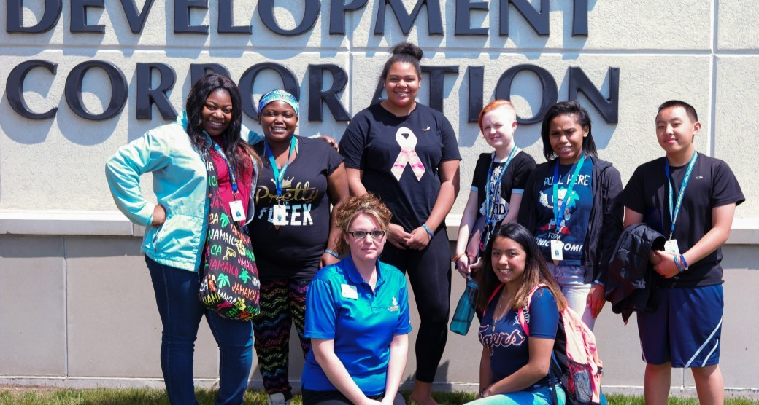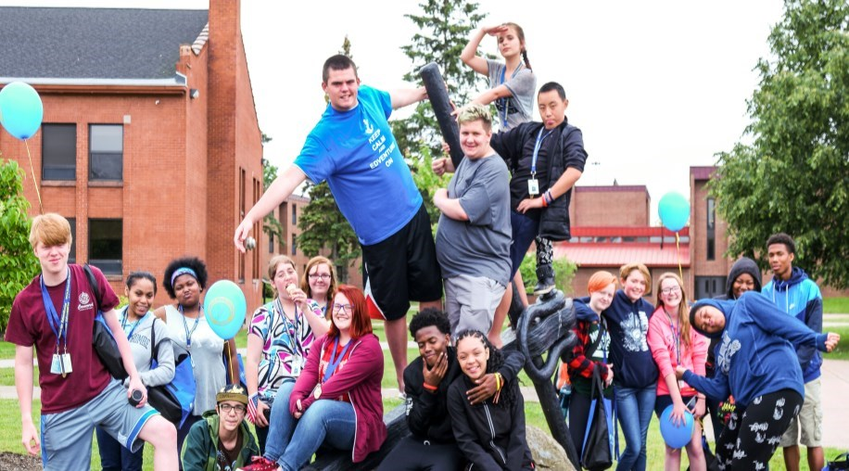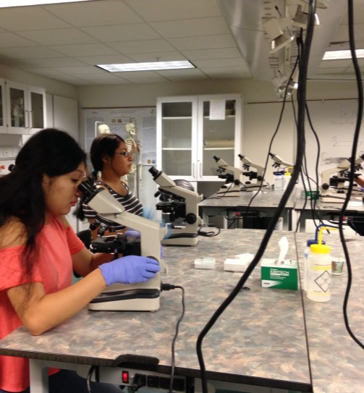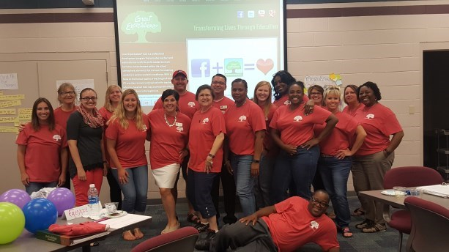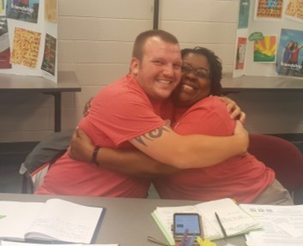

COMPLIANCE CORNER

◻

If you have any questions regarding
compliance and/or Epicenter requirements,
please direct them to:

Jenny Peterman

jpeterman@lssu.edu

906
-
635
-
2121

FINANCE UPDATE

Recently, we asked for access to each of your FID
portals; please contact Becky if you have not
completed the required form. Thank you to those
of you who have completed everything.

•

Sept. 29
–

Budget Revision 2018 FY

•

Oct. 27
–

Quarterly Financial Statements for
1
st Quarter 2018 FY

•

Nov. 1
–

Financial Audit and Letter to those
Charged with Governance

•

Nov. 14
–

Financial Audit Database

Welcome back to the 2017
-
18
academic year.
Your field representatives look forward to work-
ing with you.

Melissa Weisberger, mweisberger@lssu.edu
Advanced Technology Academy, American International , Detroit
(
Service Learning/ Redford Service Learning, Sarah J. Webber)

John Chandler, jchandler1@lssu.edu
)
(
ICademy, Innocademy Allegan and Zeeland, Ridge Park

Larry Kubovchick, lkubovchick@lssu.edu
Bay City, Charlton Heston, Concord Boyne, Concord Petoskey,
(
Detour, Grand Traverse Academy)

Garnet Green, ggreen3@lssu.edu
Macomb, Momentum, Tipton, WAY Academies, WSC
(
)

-
FROM THE FIELD
-

Smiling faces, new friends, cheerful chatter, unique experiences, and sweet exhaus-
tion. Throw in some learning and what you have is another successful summer of
camps at LSSU, provided by LSSU’s Charter School Office and Superior Edventures.

Dedicated to providing unique and potentially life
-
changing experiences for LSSU
charter school students, the LSSU Charter School Office once again, financially and
logistically, supported summer camp experiences for roughly 700 participants from
LSSU charter academies this past summer. Under the design and direction of the
Superior Edventures office, students enjoyed a wide variety of learning and growing
experiences.

2017
was the fourth summer for both the Charter School Office’s high school Career
Exploration and Leadership Camp, and the middle school STEAM (Science, Technol-
ogy, Engineering, Art, and Math) camp. Academy specific camps/experiences were also created fpr WAY Flint, Ridge Park,
Tipton, and Advanced Technology Academies.

Lastly, 21 Charter School Office scholarships were utilized by students to attend high school academic camps including career
s
in Natural Resources, Biomedical Science, Forensic Science, Aquatic Ecology and Fisheries, Criminal Justice, and Photog-
raphy.

The Charter School Office and Superior Edvetures is already looking forward to the summer of 2018, with the goal of having
even more participants taking advantage of these truly unique and memorable experiences.

Submitted by Keith Kranke

College and Career Readiness Coordinator

NEW Requirement

With the passage of HB 4822 a.k.a. the “3rd
Grade Reading Law,” beginning in 2017
-
18
,
academies will be required to assess K
-
3
rd
graders in reading by a state approved assess-
ments. Students that are deficient must be
given an Individual Reading Improvement
Plan and parents must be notified of their
child’s deficiency and plan of action. For
more information, go to https://mea.org/
learn
-
whats
-
in
-
the
-
new
-
third
-
grade
-
reading
-
law/

-
Newsworthy
-

Great Expectations: Great Time

Over twenty five participants attended Great Expectations training in Bay City on August 16th and 17th. What
is Great Expectations? Great Expectations is a program that is based on the core beliefs that through a climate
of mutual respect, high expectations , and positive teacher attitude , academic excellence can occur.

As mentioned in the July newsletter, LSSU CSO will be implementing a Quadrant Intervention System where
we identify those academies that are experiencing lower growth and cohort achievement based on their 2016
-
academic report. These academies will receive priority status for professional development and support by
17
the charter school office. In September and October, I will be visiting academies to
discuss your 2016
-
17
performance and answer any questions. Academy boards will
receive an “Academic Snapshot” which is an abbreviated version of the more de-
tailed annual report for academy administration. I look forward to visiting with all
you. Julie Hopper, Academic Assessment Specialist

