How to Register using Anchor Access

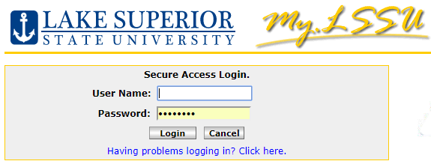
Logging in to My.LSSU.edu
Go to http://my.lssu.edu. Enter your username and password, found in your acceptance letter, and click Login. If you do not know your LSSU username and password, please contact the Registrar’s Office at 906-635-2682.

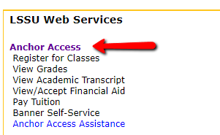
Navigating Anchor Access
After logging in, choose Anchor Access, found in LSSU Web Services. Click the Student tab, select Registration, then select Add or Drop Classes (Register). Choose the term you wish to register for and click submit. For help selecting a class schedule, please see your academic advisor.
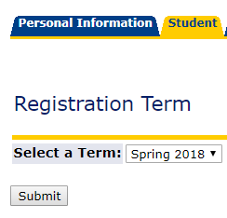
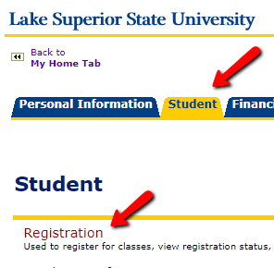
Registering for Classes from the Add or Drop Classes Page:

If you know the Course Reference Number (CRN – 5 digit number):
- Enter the CRN in the boxes below Add Classes Worksheet
(you can enter multiple CRNs at one time, one per box)
- Select Submit Changes to register

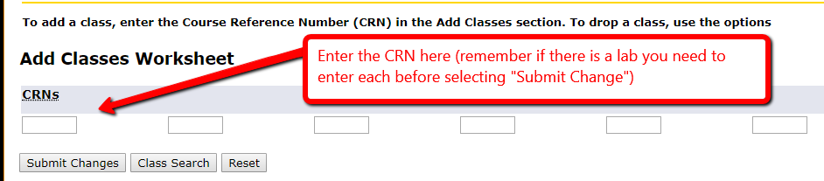

If you don’t know the CRNs, there are three options you can choose to register:
1) Class Search Option (search all sections by Subject):
- Select the Class Search button
- Select Subject from the list (i.e. Communication)
- Click Course Search, then View Sections
- Click the Select box next to the section(s) you want, then click Register
- Continue until you are registered for all needed courses

2) Advanced Course Search Option (search by Subject or Course):
    - Select the Class Search button, then Advanced Search
    - Select your subject or enter course # (i.e. COMM 101)
    - Click Section Search, check box next to the section(s) you want, then click Register
    - Continue until you are registered for all needed courses

3) Add to Worksheet Option:
    - Use either Class Search or Advance Course Search to find course
    - Choose Select box next to the section(s) you want; click Add to Worksheet
    - The CRN is added to the Add/Drop Classes page
    - Continue searching and adding courses to the worksheet
    - When you are done adding courses, click Submit Changes to register

Printing and Viewing Your Class Schedule
Using the blue links on the bottom of the Add or Drop Classes page, you can select different viewing and printing options of your schedule.

Common Registration Errors:

PREQ and TEST SCORE-ERROR: This error indicates that you do not have the correct prerequisite requirements to register for this course. To view the prerequisite requirements, click on CRN, then click on View Catalog Entry. All requirements are listed. If you would like to be registered regardless of the prerequisite requirement, you will need to talk to the instructor. Only the instructor can complete an Instructor Override allowing you to register.

LINK ERROR: L2 REQUIRED: Many courses have both a lecture and a laboratory component. The lecture and laboratory sections are “linked” together. To register for a course containing both a lecture and laboratory, you will need to add both CRN’s on the Add Classes Worksheet, then click Submit Changes. For other registration errors please see our Common Registration Errors Worksheet.

Helpful Web Links

- Home Page: https://www.lssu.edu/
- My.LSSU: https://my.lssu.edu/cp/home/displaylogin
- Course Scheduling Information: https://www.lssu.edu/registrar/scheduling/
- Common Registration Errors: http://www.lssu.edu/wp-content/uploads/2017/05/adderrors.pdf

If you run into problems or have any questions, please call the Registrar’s Office at (906) 635-2682, or send an email to: registrar@lssu.edu. We are here to help.

January 2018

