

Congratulations! You have been selected to participate in STEAM Camp at Lake Superior State University from July 8-11, 2019. Please complete the Health History and Release of Liability Form/Travel Release Form with signatures and submit to your school administrator. The included forms are required for camp participation. The climbing wall is an optional evening activity in the Norris Athletic Building. Parents - if your student-camper wants to participate, the Rock Climbing Assumption of Risk and Waiver of Liability form (last page) must be signed by the parent or legal guardian. The swimming pool will be closed for repairs during July but there may be trips to the local beach on Lake Superior or the Saint Mary’s River so still bring your bathing suit and a beach towel. Every year personal items get left behind so it is a good idea to label as much as possible so we can make sure they arrive home with you.

WHAT TO BRING

- The University will supply bed linens, one set of towels and a blanket. The participants must supply their own toiletries. Optional items to bring: a small portable fan in case the weather gets hot, extra pillow and a beach towel.

- Clothing and other suggested items: water bottle, back-pack, bug repellant, sun screen, personal hygiene products, shorts, tennis shoes, swimsuit (for evening activities), light jacket, rain jacket/poncho, long pants, as well as older clothes suitable for outdoor activities. The weather can be unpredictable in July and vary from cold, windy, wet, 50’s to warm, sunny, and dry 80’s. Dress during the program will be casual. Again, please label as many personal items as possible.

- Spending money for incidental expenses such as to order pizza/snacks in the dorm and also to buy souvenirs at the bookstore. Spending money is optional as 3 meals a day are provided and all camp activities are paid by Superior Edventures.

- Cell phones and digital devices are allowed at camp; however, campers are responsible for care of their items. We do not allow use of these items during academic sessions.

How do I contact Superior Edventures staff during camp? 24- Hour Emergency Telephone 906-635-2100 Superior Edventure Camp Office 906-635-6673



STEAM Camp
July 8 – July 11, 2019
Science Technology Engineering Arts Math

Superior Edventures is proud to offer you a summer camp which blends fun with learning. Lake Superior State University’s campus is located in the beautiful Upper Peninsula of Michigan, where we invite you to stay with us and enjoy what we have to offer. Our STEAM camp will provide students with an eclectic range of activities, games, and labs taught by current Lake State faculty and students.
Please type or print all information.
Personal Information

Name (Last, First, Middle):

Address: |  |  |  |  |  |  |  |  |  |  |  | Date of Birth:
City: _ |  |  |  |  |  |  |  |  |  |  |  | Age: |  |  |  | Gender: □ Male □ Female
State: |  |  |  |  | Zip Code: |  |  |  |  |  |  | Phone:
Email (required):
Name of Parents or Guardians:
Grade Entering in Fall 2019 |  |  |  |  |  |  |  |  |  | □ 7th | □ 8th
Name of Current School:

For more information, contact your school counselor or Lauren Paitson at: 906-635-6673

Or
lpaitson@lssu.edu

Superior Edventures reserves the right to terminate the stay of any student when it is deemed to be in the best interest of either the student or the Summer Camp.

REGISTRATION: Students register at the Cisler Center
th
at LSSU on Monday, July 8 at 2:00pm.

DEPARTURE: Thursday, July 11 at 2:00pm.

Superior Edventures reserves the right to terminate the stay of any student when it is deemed to be in the best interest of either the student or the Summer Camp.

STEAM Camp 2019

Camp Name & Session

Participant Consent to Treat, Release of Liability, Insurance Information, and Health History Form

(MUST be completed to participate)

Student Information (Please Print)

q Male q Female

Student’s Full Name |  |  |  |  |  |  | Birth Date |  |  |  |  | Grade
Address
City |  |  |  |  |  |  |  | State |  |  | ZIP
Grade Entering |  |  |  |  | School Name

Parent/Guardian Information

Each Parent/ Guardian must fill out the following information.

Mother’s/Guardian’s Full Name

Day Phone ( |  | ) |  |  | Evening Phone ( | ) |  |  | Cell | ( | )
Father’s/Guardian’s Full Name
Day Phone ( |  | ) |  |  | Evening Phone ( | ) |  |  | Cell | ( | )

Emergency Contacts

Please note that the emergency contacts should be individuals other than the parent/guardian’s listed above. (In the event of an emer-

gency, the parent/guardian is the initial contact.) This information is mandatory.
Name |  |  |  |  |  | Relationship to Participant
Day Phone ( |  |  | ) |  | Evening Phone ( |  | ) |  |  |  | Cell | ( | )
Name |  |  |  |  |  | Relationship to Participant
Day Phone ( |  |  | ) |  | Evening Phone ( |  | ) |  |  |  | Cell | ( | )

Release of Student

No student shall be released without permission of the program director and without completion of the release below. For safety rea-sons, the student will not be released to unauthorized individuals. In case of emergency

may be released to the following people:
Name |  | Phone
Name |  | Phone
Parental Consent
In consideration of the acceptance of |  |  | as a participant in the Superior Edventures
Summer Camp Program, the applicant agrees that Lake Superior State University and/ or its staff, coaches, or employees will not be held responsible for any accidents or loss of personal property, however caused, and agrees to release the University from all claims or damages which may arise as a result of such accidents or loss. It is further agreed that all risks attendant to watching and/ or participating in the Superior Edventures Summer Camp Program are assumed by the student and his/ her parents and/ or guardian and that this assumption is acknowledged, approved by their signature hereto. The Superior Edventures Summer Camp Program reserves the right to use any pictures taken during the program for advertising and/ or instructional purposes. I/ we have read the foregoing, have explained it’s meaning to our son/ daughter or ward, and understand and approve of consent to the terms and conditions as stated.

X) Signature of Parent/Guardian |  | Date
 | 1 of 4

Health History

Please circle the medical problems the participant has had or is currently experiencing.
Asthma | Back Problems | Epilepsy | Allergies | High Blood Pressure
Dislocations | Joint Problems | Heart Problems | Diabetes | Other

For any conditions checked above, please describe symptoms/conditions, how often they occur, how long they last, and how you take care of them.

Does the student currently have any infectious diseases? If so, explain:

Does the student have any limiting physical or health disabilities or handicaps (temporary or permanent) that the student or the doctor feels would limit the participation in this program? If so, explain:

Please explain in detail any additional information on any behavioral or emotional limitations that the student might have.

Name of Participant’s Doctor
Day Phone ( | ) |  |  |  | Evening Phone ( | )
Address |  |  |  |  | City |  |  | State | ZIP

Date and location of the participant’s last physical exam

Does the student have any food allergies? Or, dietary requirements?

Are all immunizations up to date? (circle one) Yes |  | No
Date of last tetanus shot
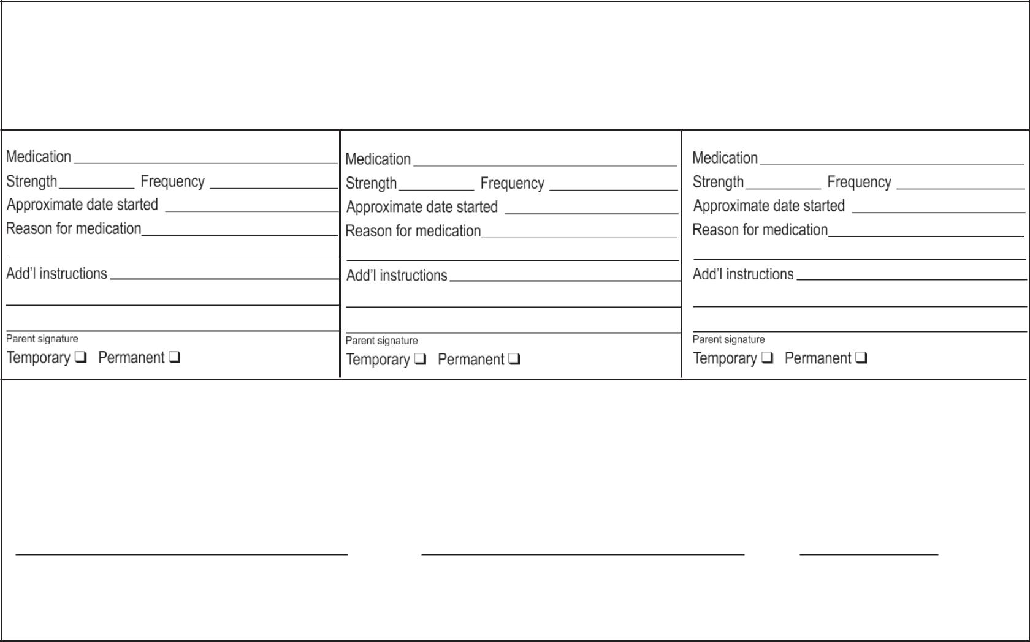

Medications

List all medications currently used. (If additional space is needed, please photocopy this part of the health form.) Inhalers and EpiPen information must be included, even if they are for occasional or emergency use only.

Medications can be turned in at registration and will be distributed as directed by the Head Counselor for resident students.

I understand that:
- Prescription medications must be taken according to my doctor’s or pharmacist’s instruction.

- It is never appropriate to allow other people to take my prescription drugs and that doing so will result in expulsion from summer camp and/or referral to police and other authorities.

- If my prescription is required for serious allergies (i.e. inhalers, Epi-pens), I should carry these items with me at all times.

- I must self-monitor and take my medications appropriately.

Student Signature Parent Signature Date

Note: Parents are responsible for ensuring that students have enough of any necessary medicine to get through the week.
Please do not send extra unless it will be needed.

2 of 4
Treatment Authorization

I do hereby authorize Lake Superior State University to seek any emergency or routine medical or surgical treatment necessary for the care of my child, and I authorize Superior Edventures to give my child the following as needed (circle):

Tylenol |  | Ibuprofen | Pepto Bismol | Benadryl |  | None | Other
(X)
Signature of Parent/Guardian |  |  |  |  |  | Date

In the case of illness and/ or injury, permission is granted for medical treatment to be rendered to my son/ daughter. I understand that I will be notified in case of serious illness. All medical bills incurred by the patient will be the responsibility of the parent or guardian. My child is medically fit to participate in the Superior Edventures Summer Camp Program.

(X)

Signature of Parent/Guardian |  |  |  | Date
Insurance Information |  | Do you have health insurance? (Circle one) Yes No

If Yes, please provide the name and address of insurance company:

All relevant policy, plan, and/or group numbers for the health insurance:

Policyholder’s name, relationship to student, and address:

If No, you must read and agree to the following acknowledgement of risk statement. Your signature on this form indicates your consent.

I have no health insurance. I understand the risk, and I take responsibility for any injury my child may receive. I will assume responsibility for all costs incurred.

Signature (X)

Name and address of policyholder’s employer: |  |  |  |  | Date
Work Phone Number ( | )

If you have HMO, HIS, or PHP insurance, please list emergency phone number for treatment authorization purposes:

Participant Behavior Agreement

Lake Superior State University’s Superior Edventures Summer Camps reserves the right to terminate the stay of any student when it is deemed to be in the best interest of either the student or the program as determined by the University and its staff. The University and program staff expressly reserves the exclusive right to establish and determine the standards of conduct, behavior, and performance of the participants engaging in the program and to require compliance with such standards as a condition of participation in the program. Students who do not follow these rules, or engage in dangerous or inappropriate behavior, will be expelled from the program at their own cost. Examples of inappropriate behavior includes, but is not limited to, such things as causing disruptions in class, the use of profane language, and the repeated violation of minor rules. This is not a complete list. If you have any further questions about what behaviors are unacceptable, please contact our office at (906) 635-6673. The University requires that you read these regulations with your parent/guardian(s). Your signatures indicate that you understand and accept them as a part of your participation in Lake Superior State University’s Superior Edventures summer camps.

X)

Signature of Participant |  |  |  | Date
X)
Signature of Parent/Guardian |  |  |  | Date
 |  | 3 of 4

Summer Camp Transportation Form

Permission for transport for all summer camp participants.

I hereby give permission for as a participant Superior EDven-
tures Summer Camp Program, to travel to and from any / all destinations for the entire week of summer camp by LSSU staff.

I understand that the driver, and Lake Superior State University are not responsible for any injury or damages which may be incurred on said trip, and in consideration for providing transportation, I agree to hold Lake Superior State University, as well as the drivers and owners of the vehicles transporting the student, harmless from claims for injury or damages occurring during said trip.

X)
Signature of Parent/Guardian Date

O I give permission for the following individuals to pick up my child from camp.

Name:

Name:

X)
Signature of Parent/Guardian Date

O My son /daughter will be driving to camp. The overnight participant will be required to turn his/her vehicle keys over to the Superior Edventures Staff for the duration of their stay at LSSU. N/A for STEAM Camp

X)
 | Signature of Participant | Date
X)
 | Signature of Parent/Guardian | Date

650 W. Easterday Ave., Sault Sainte Marie, MI 49783 • Telephone: 906-635-6673 • Fax: 906-635-2695

4 of 4

Lake Superior State University
Rock Climbing Wall

Assumption of Risk and Waiver of Liability
Under 18 Years of Age

By signing this release as the parent or legal guardian of a child under the age of 18, you acknowledge and agree to the following:

Assumption of Risks

I acknowledge and accept that rock climbing involves risks, dangers, and hazards. The inherent risks, hazards and dangers include but are not limited to: sprains, strains, dislocations, amputations, cuts, bruises, breaks, teeth (loosened/broken/knocked out), head injuries, concussion, paralysis, and/or death. I understand, accept, and assume those hazards and risks, and waive all claims against Lake Superior State University, its Board of Trustees, officers, agents, representatives and employees, further known as LSSU and any other business or person connected with the rock climbing wall, of all claims for injuries or damages or otherwise, which may

arise for any reason whatsoever as a result (minor’s name) participation in the Lake Superior State University’s Rock Climbing Wall.

I am aware of the risks, dangers, and hazards associated with rock climbing and I freely accept and fully assume all such risks, dangers, and hazards and the possibility of the personal injury, death, property damage or loss resulting from participating at Lake Superior State University’s Rock Climbing Wall.

Parent/Legal Guardian Initials: Date:

Release of Liability, Waiver of Claims, Assumption of Risk and Indemnity Agreement by Parent/Legal Guardian
In consideration of my child’s participation at LSSU’s Rock Climbing Wall, I hereby agree to the following:

- To waive any and all claims that the participant now has or may in the future have against Lake Superior State University and to release LSSU from any and all liability for any loss, damage, expense or injury including death, that the participant may suffer or that his/her next of kin may suffer as a result of participant’s participation in activities at LSSU’s Rock Climbing Wall, due to any cause whatsoever, including the negligence of the Releasees, negligence of other rock climbers, and including failure on the part of the Releasees to safeguard or protect me from the risks, dangers and hazards of rock climbing referred above.

- To hold harmless and indemnify LSSU from any and all liability for any property damage or personal injury to any third party resulting from participants participation in rock climbing.

- This agreement shall be effective and binding on the participant’s heirs, next of kin, executors, administrators, assigns and representatives in the event of the participant’s death or incapacity.

I confirm that I have read and understood this agreement prior to signing it, and I am aware that by signing this agreement I am waiving certain legal rights which I or my heirs, next of kin, executors, administrators, assigns and representatives may have against Lake Superior State University.

Signature of Participant

Parent/Guardian’s Signature

Date

