Proposed Budget Review and Planning Process
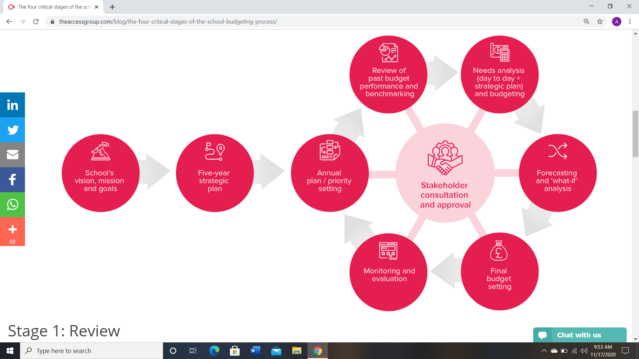
Source: Access – theaccessgroup.com
The Four Critical Stages of the School Budgeting Process

