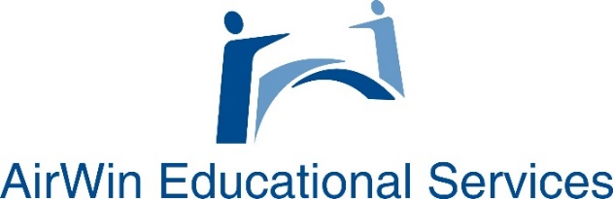

Board Meeting Materials’ Review
Guidance and Wise Questions Template

Agenda Review (general comments/questions):
- Do any of the agenda topics have policy implications?
- Is the content familiar? Are there any unfamiliar items listed on the agenda? Do I/we need further clarification on any of the agenda topics?
- What is going to require action? What is informational? (Tip: If informational items are going to add considerable amounts of time to meeting conversation, consider adjusting to future meeting(s)) Do you have the necessary support documentation/materials to make informed decisions?
- Does the agenda appear to be conducive to a 90-120 minute meeting?

Review Guidance:
- Consider agenda topics and determine what has policy implications, if anything
- If the agenda contains unfamiliar content, discuss with relevant parties (in advance) the unfamiliar topic and expectations relative to board consideration/action
- Ensure that support materials make sense to you and offer the necessary decision-making guidance; if additional support materials are required, be sure to request those materials in advance of meeting
- Be sure that the agenda contains subjects that are relevant to the present meeting versus items that can be discussed at a later meeting (especially if the agenda is already loaded with information)
- Review agenda topics with action plan template to ensure that attention has been given to follow-up
- Apply timeframes for discussion items

Academics:
- Are the principal reports encouraging outcomes-based board discussion?
- Is the Board receiving the principal reports in advance? (Hint: Encourage the reports be provided as part of the Board packet and use the meeting to ask questions about the report(s) versus the report being shared, in its entirety, by the principals.)
- Is there enough information contained within the principal reports that the board can ask questions concerning desired outcomes for reported inputs (i.e. if the school is planning a field trip to the African-American Museum, what does the school hope to achieve/accomplish from that trip? What is the “return on investment” proposition?)
- Is the board ensuring that the school is on track for meeting its contracted academic goals? If academic deficiencies, is management addressing how those deficiencies are being satisfied? Are there financial implications? What is the Board’s role in ensuring academic and financial strategies are aligned (see “financials” below)?
- Are there any academic elements that require the attention of the authorizer?
- Does every board meeting provide for significant academic discussion?

Review Guidance:
- Ensure that the agenda/materials offer an academic reporting format that tracks progress toward goals
- Ensure that academic achievement and growth is being discussed at every board meeting
- If necessary, ensure that specific strategies are being addressed/implemented to improve proficiency and growth
- Ensure academic reports include both formative and summative approaches to impact improvements (If board does not understand formative and summative assessments, ask.)
- Establish protocols for communicating with the authorizer

Financials:
- Are there variances from original, approved budget and/or amended budget to actual expenditures? If so, does the board understand why or will it require explanation?
- Is the board ensuring key programs are adequately funded?
- Is the board paying attention to financial commitments that support strategies to improve academic performance? Is the board encouraging those?
- Is the board tracking percent of revenues spent for instruction?
- Are there any financial elements that require the attention of the authorizer?

Review Guidance:
- Look for variances
- Review key programs and calculate funding based on financial reviews
- Be certain that the financial reports include commitments that support academic improvement strategies
- Review and/or be prepared to ask about percentage of revenue spent on instruction
- Establish protocols for communicating with the authorizer

“Other” Items:
- Has the board and management/leadership identified operational issues to be discussed at board meetings? If so, are they being discussed?
- Has the board established cultural/climate expectations? And are those expectations being discussed, consistently, at board meetings?
- Are there any items on the agenda that do not fall into either academics or financial(s) discussion? If so, what are they?
- How are these items being addressed at board meetings?
- Has the Board and management established a format for addressing these items?
- What is the Board’s appropriate role in these discussions?
- Do any of these items have board policy implications?
- How are these items impacting academic achievement/outcomes?
- Are implemented measures achieving the desired outcomes?

Review Guidance:
- Identify operational/cultural/climate items and, as indicated above, if clarity is needed regarding the items, communicate with relevant parties in advance of meeting
- If have not already done so, discuss/agree upon reporting format for addressing these items at board meeting
- Always think about operational/cultural and climate topics in terms of outcomes
- When reviewing these agenda items, think about the board’s role in subjects/discussion(s); if unclear, communicate with relevant parties
- Always ensure that all of these discussions/decisions are in alignment with board policy

