**Buckthorn Invasion Model**

**Topic:** Invasive species and food webs

**Target Grade Range:** Middle school

**Time:** Around 15-20 minutes

**Category:** Model/Game

**Summary:** Students will model the relationship between invasive species and native species and how their relationships can affect the ecosystem.

**Goals:**

* Students understand how invasive plants are spread by other species in an ecosystem
* Students understand how invasive plants can alter an ecosystem

**Objective(s):**

* Students model how invasive buckthorn plants are able to outcompete native plants in a terrestrial ecosystem.
* Students observe changes in bird habitat in a forest ecosystem as buckthorn population increases.

**Background knowledge:** Students should understand the basics of what a food web is and how it works. Students should be familiar with invasive species and why they are harmful to our ecosystems.

Resource: Introduction to invasive species video, Michigan Department of Environment, Great Lakes, and Energy (MI EGLE), *Invasive Species: The Basics* (<https://www.youtube.com/watch?v=yIgysZ5Hho8>)

# **Procedure:**

# *Materials:*

* Pictures of native food sources, birds, aspen trees and buckthorn tree (see Buckthorn Invasion Model Pictures resource)
* Envelopes
* Painters Tape (or similar light adhesive for wall or whiteboard mounting)
* Introductory presentation (see Buckthorn Invasion Model Introductory Presentation)

*Set-Up:*

* Print and cut out pictures from the Buckthorn Invasion Model Pictures
* Prepare envelopes for each of the three rounds so every participant gets a “food” picture. The following are the food picture ratios:
  + Buckthorn berries
    - Round 1: ~15%; Round 2: ~40%; Round 3: ~75%
  + Regular bird food pictures (i.e., worms, fruit, and mayflies)
    - Round 1: ~85%; Round 2: ~60%; Round 3: ~25%
  + The total* number of pictures in each envelope equals the number of participants (e.g., students).

*Total number of pictures = buckthorn berry pictures + bird food pictures

* Tape aspen tree pictures to a wall, each picture ~1-3 inches from another picture.
  + Pictures could be in a 4-by-4 grid square or a more non-formatted cluster as long as each picture is within ~1-3 inches of each neighboring picture.

**Example aspen tree formats are below.**

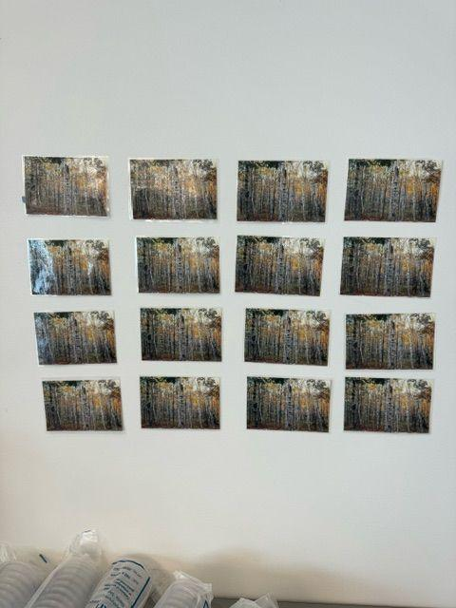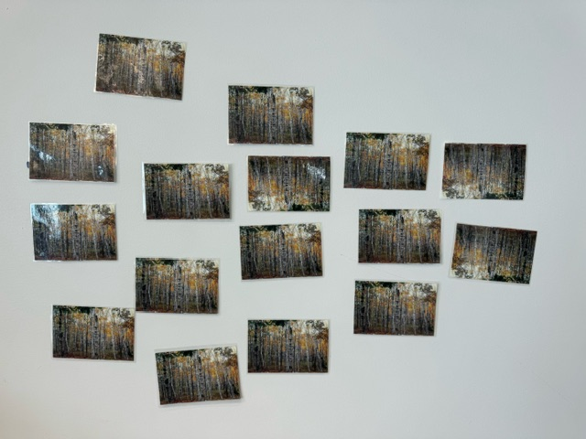

* + Put tape on the back of the photos of buckthorn branches and set them on a table upside-down, tape side up.
  + The total photo cards with tape should match the total number of buckthorn berry food cards across all 3 ‘rounds’.
* Set up a graph on a whiteboard or computer for projection: x-axis is the round number–1, 2, or 3; y-axis is buckthorn count
* Set up a computer and projector to show the introduction slides

*Activity Description:*

*Note: Only run these 3 rounds* ***once****. This is not an activity that can be re-run since the data is the same.*

1. Using the Buckthorn Invasion Model Introductory Presentation, give students an introduction to common buckthorn and invasive species (slides 1-3)
   * Explain that the buckthorn berries are invasive and not good for birds to eat*

*Note a variation on this in the “Variations and Extensions” section of this activity.

1. Students will each represent a bird from the ecosystem
2. Place pictures from the “Round 1” envelope face down on a table
3. Birds choose their food from the face-down picture cards
   * Alternatively, have a participant hand out the pieces of ‘food’ with the picture facing down.
4. Birds who get buckthorn berries as their food will take one of the pictures of buckthorn branches and tape it over one of the printed aspen trees on the wall
5. Make sure to collect all of the food from each round before starting the next one.

Note: these pictures can be returned to their envelope for use with another group.

1. Repeat steps 3-6 with the corresponding envelopes for each round
2. By the end of the three rounds, the aspen trees should mostly be covered by the buckthorn trees (**Images of example outcomes, depending on starting format, are below.)**

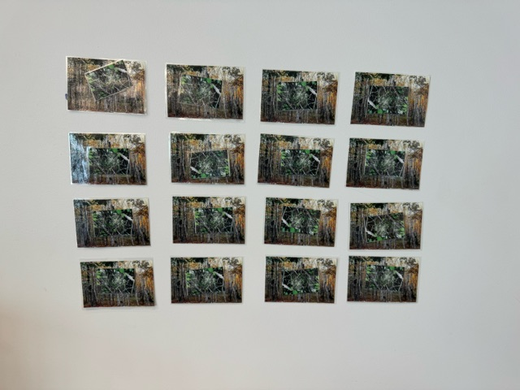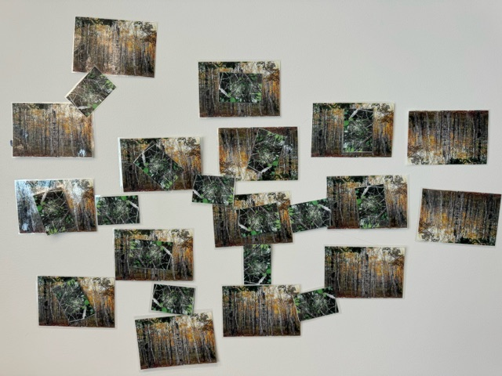

1. Wrap up by returning to the Buckthorn Invasion Model Introductory Presentation to talk more about native vs invasive species, as well as the stewardship options (slide 4)
2. Show **one of the following videos** if there’s enough time
   * Nature Conservancy of Canada, *Controlling Invasive Common Buckthorn (*<https://www.youtube.com/watch?v=cvdaiKqjW0k>) (preferred)
   * Vermont Fish and Wildlife Department, *Buckthorn* (<https://www.youtube.com/watch?v=xR3cjtoqvL0>) (a back-up))

**Discussion:**

Discuss observations and outcomes of the activity including trends in the data.

*Below are sample inquiry questions based on collected data* (allow for open discussion)

Example student answers/comments are in red.

* What happened to the ecosystem over time?
  + Buckthorn began to increase in number in the forest.
  + Food sources for wildlife began to reduce.
  + Wildlife population decreased as healthy food sources diminished.
  + The once-diverse aspen forest became a plant monoculture with limited wildlife
* What can you do to prevent this scenario in real life?

Students might suggest:

* + - reducing the spread of invasive species by cleaning boots/shoes to remove seeds before moving into a new space.
    - Cutting down buckthorn

Note that taking this action should be followed by covering the stumps with bags to prevent new shoots from growing (see slide 3 of the introductory presentation). In Michigan, working with your local Cooperative Invasive Species Management Area is an excellent way for students to learn about invasive species and the appropriate way to deal with invasive species. (<https://www.michigan.gov/invasives/take-action/local-resources/>)

* + - Before planting, check to see if the plants are safe (and beneficial) for local wildlife. Choose to plant species native to your area.
* What can you do to help stop this if it is already happening in an ecosystem?
  + Partner with the local Cooperative Invasive Species Management Area (CISMA) to remove buckthorn (or other invasive species) from the area.
* What do the birds do now that they don’t have good food sources?
  + The original populations of birds will not survive in this area.
  + Those that can find another diverse location with a variety of food will move.
  + Migratory birds might still stop in this area and eat the buckthorn berries before leaving carrying seeds with them to another location.

**Variations and Extensions:**

* The activity can be run virtually or hybrid
  + Virtual students can use two dice or a virtual dice roller (<https://www.calculator.net/dice-roller.html>) to randomly choose their food item
    - Round 1: dice value 2-6 = worm; 7 = buckthorn berry; 8-12 = fruit
    - Round 2: dice value 2-6 = worm; 7&8 = buckthorn berry; 9-12 = fruit
    - Round 3: dice value 2-5 = worm; 6-8 = buckthorn berry; 9-12 = fruit
* Student discovery (See “Talking Points” at the end of the document): Don’t reveal that buckthorn is invasive until after the game has ended. In this case, students use data from the model ecosystem to analyze and interpret what happened between the buckthorn and aspen trees and the four food sources– buckthorn berries, worms, mayflies, and fruit. Only use the first and second slides of the introductory presentation to hint at it being invasive before the game. Show the native vs invasive slide (#3) with the last slide (#4) after the game concludes.

**Additional Resources:**

* *Food Web*, National Geographic <https://education.nationalgeographic.org/resource/food-web/>

Note: This much detail isn’t necessary, just basic understanding

* *Invasive Species: Common Buckthorn*, Michigan Department of Natural Resources <https://www.michigan.gov/invasives/id-report/plants/shrubs/common-buckthorn>

**Research Connections:**

**Lake Superior State University Center for Freshwater Research and Education (LSSU CFRE) *Hydrocharis morsus-ranae* (European frogbit) research:**

CFRE research teams collaborate with EGLE and Three Shores CISMA to conduct field and lab experiments on the invasive plant European frogbit. The goal is to gain more knowledge on the distribution and winter survival of the species as well as how to effectively remove it.

**Lake Superior State University Center for Freshwater Research and Education (LSSU CFRE) *Didymosphenia geminata* (didymo) research:**

CFRE research teams conduct lab experiments and field sampling for didymoin order to understand what is causing the growth of the invasive algae. LSSU CFRE also conducts eDNA and water quality analyses. University of Wisconsin Oshkosh, Michigan Sea Grant, and EGLE all partner with CFRE on this project.

**Michigan Department of Education Standards**

Next Generation Science Standards Performance Expectations

**MS-LS2-4** Construct an argument supported by empirical evidence that changes to physical or biological components of an ecosystem affect populations.

**MS-LS2-1** Analyze and interpret data to provide evidence for the effects of resource availability on organisms and populations of organisms in an ecosystem.

*This activity provides background information to support the following standards*

**MS-ESS3-3** Apply scientific principles to design a method for monitoring and minimizing a human impact on the environment.*

**MS-LS2-5.** Evaluate competing design solutions for maintaining biodiversity and ecosystem services.*

**MS-LS2-1** Analyze and interpret data to provide evidence for the effects of resource availability on organisms and populations of organisms in an ecosystem.

Math

*Standards for mathematical practice*

4 Model with mathematics

*Grade Level Standards*

Measurement and Data: represent and interpret data

Social Studies

**6 - G5.1.1** Describe examples of how humans have impacted and are continuing to impact the environment

*This activity provides background information to support the following standards*

**7 – G5.1.1** Describe examples of how humans modified the environment in the era being studied.

**7 – G5.1.3** Explain how people defined and used natural resources in the era being studied.

**3 – G5.0.2** Locate natural resources in Michigan and explain the consequences of

their use.

**4 – H3.0.7** Describe past and current threats to Michigan’s natural resources and

describe how state government, tribal and local governments, schools, organizations,

and individuals worked in the past and continue to work today to protect its natural

Resources.

*This activity provides background information to support the following 5th grade standard*

**5 – P4.2.1** Develop and implement an action plan and know how, when, and

where to address or inform others about a public issue.

## Talking Points (scripted format):

Consider using this guide as part of the variation where buckthorn is not revealed as an invasive species until after the activity. Use slides 1 and 2 from the Buckthorn Invasion Model Introductory Presentation

“Do any of you know what an aspen ecosystem is?”

*Leave a moment for answers– many will likely recognize the name of the tree–then show slide 1.*

“This is an aspen forest that we will be modeling today! Some of our populations will include birds such as warblers, indigo bunting, least flycatcher, yellow-bellied sap sucker, and pileated woodpecker. We are going to imagine each of us is a bird in this ecosystem.”

“Now that you know your birds, we’re going to learn a little more about the food you’ll be eating during this ecosystem model–fruit, worms, mayflies, and buckthorn berries. Some of these foods may be familiar to you, like fruit such as blackberries, raspberries, or strawberries. Those are entirely safe for your bird to eat and will keep them well-fed as we go through the rounds of this model. This is the same with worms and mayflies– they might not look as appealing to *us*, but these foods give your bird plenty of nutrients that it needs to survive.”  
  
*Move to slide 2, Buckthorn*

“This is buckthorn. Its preferred habitat is roadsides, pastures, old fields, and woodlots– it’s been used as a decorative plant for quite some time too, so you might find some on your school’s campus, at peoples’ homes, or in a park. Its range in the US includes the East Coast and Midwest, as well as some limited areas of California and Oregon. Here’s some other quick facts about it: buckthorn spreads quickly through seeds distributed by birds and wildlife; it crowds out native shrubs and understory plants. It is a host for certain viruses, fungi, and insects. It does not provide any nutritional value to birds that eat it.”

*All envelopes for each round should be prepared before the activity begins. Have Round 1 ready with a food-picture number equal to the number of participants*

“Buckthorn berries don’t provide any nutritional value to birds and the berries move through and out of the bird’s body very quickly. The seeds are deposited in the bird droppings providing *fertilizer* in the feces from the digestive system to help the seeds to grow.”

*This is an opportunity to introduce scientific terms such as feces, scat, and defecate to identify digestive waste and the process of releasing it from the body.*

*Take out the Round 1 envelope’s food papers*

“These pieces of paper (*show one of the food papers*) will be handed out at random. They’ll be given to you face-down– don’t peek until everyone has received their food. Once that’s done, we’ll look at them together. Now that we’re ready, would anyone like to volunteer to hand out the food?”

*Once everyone has their food:*“Now, check what food you have. Anyone that ate the black round berries has eaten a buckthorn berry. You didn’t get any nutrition and the berry passed right through you and the seeds have been dropped into our aspen ecosystem. Exchange your food picture for one of the upside-down, taped photos– it’s a new buckthorn plant that you fertilized. You can put that anywhere in our aspen forest.” (*Point to the aspen forest space on the wall.*)

*Students return food papers to the Round 1 envelope. Record the Round 1 buckthorn plant total on the graph*

*Repeat similar dialogue & actions for rounds 2 and 3. Ask students their noticings about the food resources. They might notice that, as more buckthorn takes over their aspen forest between rounds, more of the food becomes buckthorn. This becomes especially evident after round 3 concludes– in which case, count out the final buckthorn number and graph it.*

“Now that we can see this huge increase in buckthorn in our graph– isn’t it strange that this plant managed to take up so much of our aspen forest? Why might that be?”

*As students share their ideas, they will identify part of the definition of an invasive species: it causes harm to the environment. Consider capturing student ideas as they are shared so all can read them and encourage participants to add on to each others’ comments. Use talking strategies to guide students toward the definition of an invasive species based on their observations in this model.*

*Gather together student ideas to reach a consensus definition of an invasive species. An individual might start with a proposed definition that others could add on to in order to result in some form of the following definition*

“An invasive species is one that is not native and whose introduction causes harm, or is likely to cause harm to the economy, environment, or human health.* What are some characteristics of buckthorn that might match this definition?”

*From this model, participants don’t have evidence to support economic or human health issues but have data that show buckthorn taking over an ecosystem.*

*Return to the Buckthorn Invasion Model Intro Presentation, slide 3, then have a student read from the slide. Add additional notes as necessary to support your curricular goals then, once done, go to slide 4, stewardship, and talk about buckthorn removal learned through the ‘background knowledge’ links mentioned earlier.*

*Open the floor to comments/questions. Once done, consider showing the video/videos linked in the activity description.*

*\*Definition of invasive species is from* [*michigan.gov/invasives*](http://michigan.gov/invasives) *(an excellent resource for invasive species information)*