**Mussel Madness Model**

**Topic:** Competition between native and invasive mussel species.

**Target Grade Range:** Elementary and middle school (can be adapted for all ages)

**Time: ~**30 min (allowing for data collection and discussion)

**Category:** model/game

**Summary:** Students model the relationship between invasive and native mussels by acting out the feeding characteristics of each species and how this impacts species survival rates.

**Goals:**

* Students understand why invasive species are able to survive and outcompete native species.
* Students understand the impact of invasive species on the survival of native species.

**Objective:**

* Students model how invasive mussels are able to outcompete native mussels in the Great Lakes.

**Background knowledge:**

* Students should have general knowledge of invasive species. Students may be familiar with invasive mussels commonly found in Michigan such as zebra and quagga mussels (see additional resources), but this knowledge is not necessary before the activity.
* An overview of how mussels obtain resources by filter-feeding might help students better understand the model and explain how only some of the collected resources count as “food”.

Resources:

* Introduction to invasive species video, Michigan Department of Environment, Great Lakes, and Energy (MI EGLE), *Invasive Species: The Basics* (<https://www.youtube.com/watch?v=yIgysZ5Hho8>)
* *Invasive Species: Zebra Mussel*, Michigan Department of Natural Resources [https://www.michigan.gov/invasives/id-report/mollusks/zebra-mussel](https://www.michigan.gov/invasives/id-report/mollusks/zebra-mussel#:~:text=Zebra%20mussels%20have%20been%20known,pipes%20and%20other%20underwater%20structures).
* *Invasive Species: Quagga Mussel*, Michigan Department of Natural Resources [https://www.michigan.gov/invasives/id-report/mollusks/quagga-mussel](https://www.michigan.gov/invasives/id-report/mollusks/quagga-mussel#:~:text=Quagga%20mussels%20can%20attach%20to,and%20the%20Ponto%2DCaspian%20Sea).
* Introduction to freshwater mussels of Michigan: <https://mnfi.anr.msu.edu/pdfs/FreshwaterMusselsOfMichigan.pdf>

**Procedure:**

# *Materials:*

* Painter’s tape
* 1”x1” different colored squares of construction paper **or** different colored poker chips
* Whiteboard, chalkboard, or poster paper and writing utensil (to record data)
* Pipe cleaners/chenille stems formed into a wristband/bracelet

*Set-Up:*

* Tape 12”x12” squares on the ground (one for each student)
* Spread construction paper or poker chips around the room between the squares (see images below)

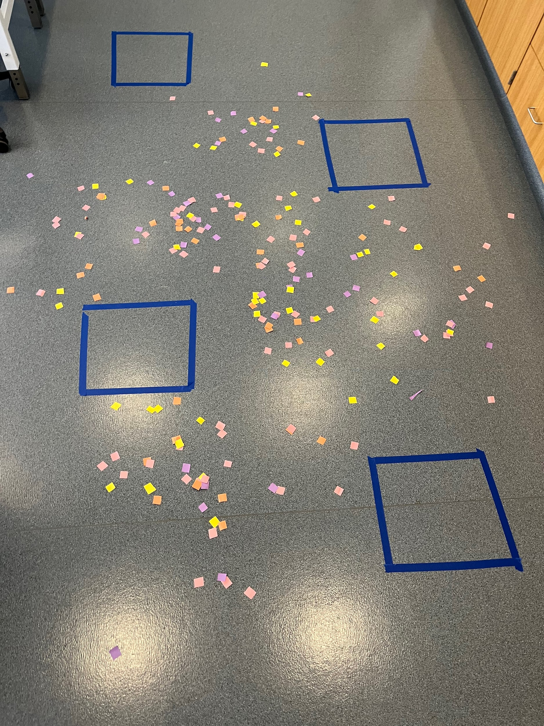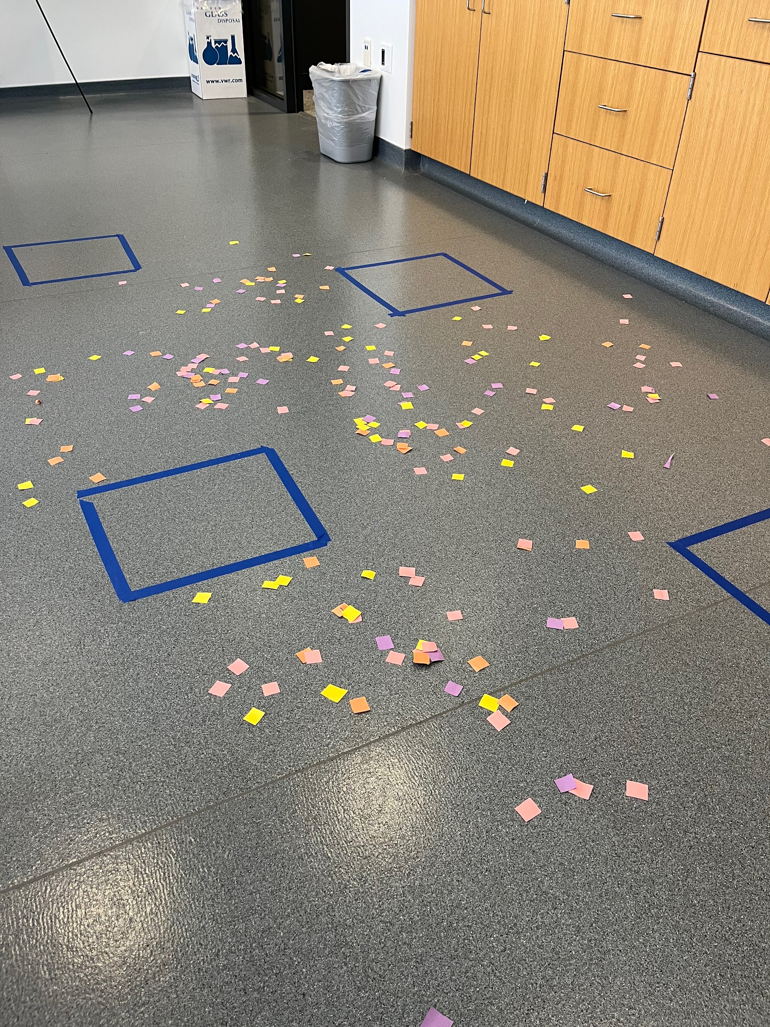

*Activity Description:*

1. Assign half of the students to stand in a square to represent mussels
   * The rest of the students should form a line to wait for their turn to be added to the model
2. Assign 1 or 2 of those students to be invasive mussels and the rest as native mussels (invasive mussels receive a pipe cleaner wristband)
3. Allow mussels 7 seconds to gather resources/food (paper/poker chips) around their square. (Time can be adjusted based on collection rate.)

Mussel Rules:

* + Mussels must stay in their square
  + All mussels can only move one resource per hand at a time
  + Invasive mussels can use 2 hands to gather resources
  + Native mussels can only use 1 hand to gather resources
  + Each resource is set in their square before going after the next one.

1. Each round, the activity leader will choose a different color to represent food but the color will not be announced until after the mussels have collected the paper/poker chips
2. If a mussel collects 2 pieces of the food color, they survive to the next round and can stay in their square. If a mussel collects 5 pieces of food, they are able to reproduce.
   * Food color is announced after collection every round
   * If a mussel is not able to get at least 2 pieces of food, they do not survive and they go to the back of the wait line
   * When a mussel is able to reproduce, assign the next student in line to an available square at the beginning of the next round to represent a new mussel.
   * If an invasive mussel reproduces, the mussel added will be invasive and will receive a wristband.
   * If a native mussel reproduces, the mussel added will be native (no wristband).
3. Record the number of each type of mussel alive at the end of the round on the whiteboard
   * If a mussel dies during the round, it is not counted as “alive” in the total at the end of the round
   * If a mussel is able to reproduce at the end of the round, the new mussel is not counted in the end-of-round total; it will be added to the model in the next round.
   * See the example Mussel Madness Model data sheet.
4. Have mussels return all resources collected to the outside of their squares before starting another round.
5. Repeat the steps for at least 5 rounds, recording mussel survival data for each round.
6. **Note: The facilitator might simulate other environmental changes by choosing “food” colors based on what mussels collect each round or by changing the number of poker chips/paper scattered around the mussels. A certain color might also represent plankton contaminated by toxins in the water so collecting a number of those might impact the survival of those mussels.**

For example:

* + Choosing a food color that has a very low collection number or decreasing the number of poker chips/paper could simulate diminished food resources that might impact all mussels’ survival rate.
  + Choosing a color that represents contaminated food would simulate the result of pollutants in the environment.
  + Choosing a food color that has a higher collection rate for one type of mussel vs. another might represent natural population variations.

**Discussion:**

* Discuss observations and outcomes of the activity including trends in the data

*Sample inquiry questions based on collected data and observations are below* (allow for open discussion).

Example student answers are in red.

* What effect did the invasive mussel population have on the native mussel population?
  + The results of this model should show that native mussel numbers decrease as invasive mussel numbers increase.
* Why did the invasive mussel population grow so quickly?
  + Invasive mussels collected more food resources each round compared to the native mussels. This allowed more to survive and reproduce compared to native mussels. Higher reproduction rates allow invasive mussels to quickly take over an area and use even more food resources.
* What do you think the invasive mussel’s advantage is over the native mussels?
  + Based on the model, students might notice that the invasive mussels have an advantage in obtaining food resources compared to the native mussels. They can collect more food in the same amount of time.
  + Note that a higher rate of water filtration by invasive mussels is a means of obtaining more food in a similar length of time compared to native mussels.
* What difference did the invasive mussel’s advantages have on its population growth? What about the native mussels?
  + If an invasive mussel filters faster, it gets more food and it will have a better chance of survival.
  + If more mussels survive, more are able to reproduce, increasing the next generation’s numbers which continues the depletion of resources.
  + Because the invasive mussels filter water so efficiently (quickly), they can remove food from the water before the native mussels can get enough to survive in large numbers and reproduce.
  + A decrease in native mussel survival reduces population growth of native mussels.
* What environmental factors might impact mussel survival rate?
  + Answers on impact will vary based on student discussions.
  + Some examples of human-caused environmental factors might include death of mussels during water draw-downs at dams, fertilizer run-off (increasing nutrients causing algal blooms), chemical pollutants, reduction of habitat due to human activity, or toxic plankton.
  + Natural environmental factors might be changing water levels due to drought, changes in nutrients in the water due to seasonal cycles, increased predators, etc.

**Variations and Extensions:**

* Create a graph using the data collected to show the increase/decrease in populations across the rounds
* Record the number of invasive vs native mussels that reproduce each round
* Poly dots can be used in place of the tape squares for younger students or for doing the activity outside

**Additional Resources:**

* *Mussels: Flexing for Water Quality*, National Park Service <https://www.nps.gov/articles/000/mussels-flexing-for-water-quality.htm>
* *Freshwater Mussels of Michigan*, Michigan State University <https://mnfi.anr.msu.edu/pdfs/FreshwaterMusselsOfMichigan.pdf>

**Research Connections:**

**Lake Superior State University Center for Freshwater Research and Education (LSSU CFRE) freshwater mussel research:**

CFRE and Michigan Department of Natural Resources (DNR) biologists do wading and snorkeling surveys for freshwater mussels, water quality, and physical habitat in Michigan’s Western Upper Peninsula (UP).

* As hydropower companies’ drawdown water (usually for repairs) freshwater mussels may become stranded and require relocation. We are researching the effectiveness of certain strategies and efforts to help aid mussel relocation.
* The research is conducted by snorkeling along the shoreline and identifying, measuring, and estimating age of found freshwater mussels. In addition, habitat characteristics are also recorded.
* Michigan Department of Environment Great Lakes and Energy (EGLE) and DNR biologists support the project. The reservoirs being surveyed are part of *We Energies* (a utility providing service to Wisconsin and Western UP).
* This project goal is to develop an effective survey approach and help hydropower facilities maximize effort and save more mussels during drawdowns.

**Michigan Department of Education Standards**

Next Generation Science Standards Performance Expectations

**3-LS4-3** Construct an argument with evidence that in a particular habitat some organisms can survive well, some survive less well, and some cannot survive at all.

**3-LS4-4** Make a claim about the merit of a solution to a problem caused when the environment changes and the types of plants and animals that live there may change.

**5-ESS3-1** Obtain and combine information about ways individual communities use science ideas to protect the Earth’s resources and environment.

*This activity provides background information to support the following 4th grade standard*

**4-LS1-1** Construct an argument that plants and animals have internal and external structures that function to support survival, growth, behavior, and reproduction.

Math

*Standards for mathematical practice*

4 Model with mathematics

*Grade Level Standards*

Measurement and Data: represent and interpret data

Social Studies

**3 – G5.0.2** Locate natural resources in Michigan and explain the consequences of

their use.

**4 – H3.0.7** Describe past and current threats to Michigan’s natural resources and

describe how state government, tribal and local governments, schools, organizations,

and individuals worked in the past and continue to work today to protect its natural

Resources.

*This activity provides background information to support the following 5th grade standard*

**5 – P4.2.1** Develop and implement an action plan and know how, when, and

where to address or inform others about a public issue.swer geographic

questions on the era and region being studied.