**Sea Lamprey Sampler Teacher Resource Document**

This document includes detailed information that students might research during the Sea Lamprey Sampler activity.

**Anatomy and Physiology (i.e., body structures and their function for survival)**

* Body structures:
  + Lampreys (in general)
    - Snout Shape: Sucking Disk (no jaw)
    - Body Shape: Eel-like, Cylindrical
    - No scales, leathery skin
  + Sea Lampreys
    - 1st and 2nd dorsal fins - separated
    - Supraoral lamina teeth - close together
    - Inner circumoral teeth - bicuspid
    - Rasping tongue
    - Papilla on mouth disc, allows for the ability to stick to a fish’s body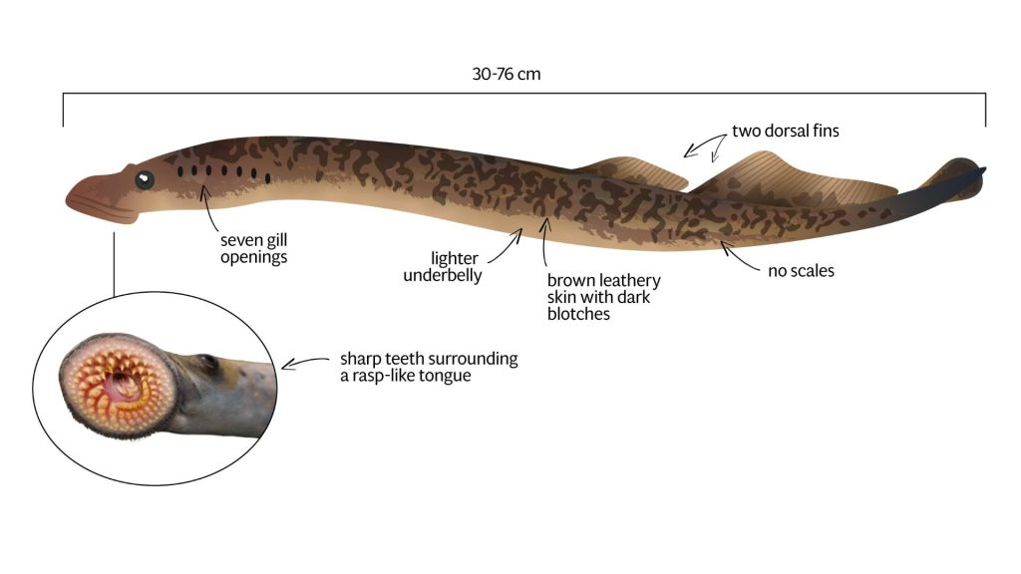

Image resource: Invasive Species Centre, <https://www.invasivespeciescentre.ca/invasive-species/meet-the-species/fish-and-invertebrates/sea-lamprey/>







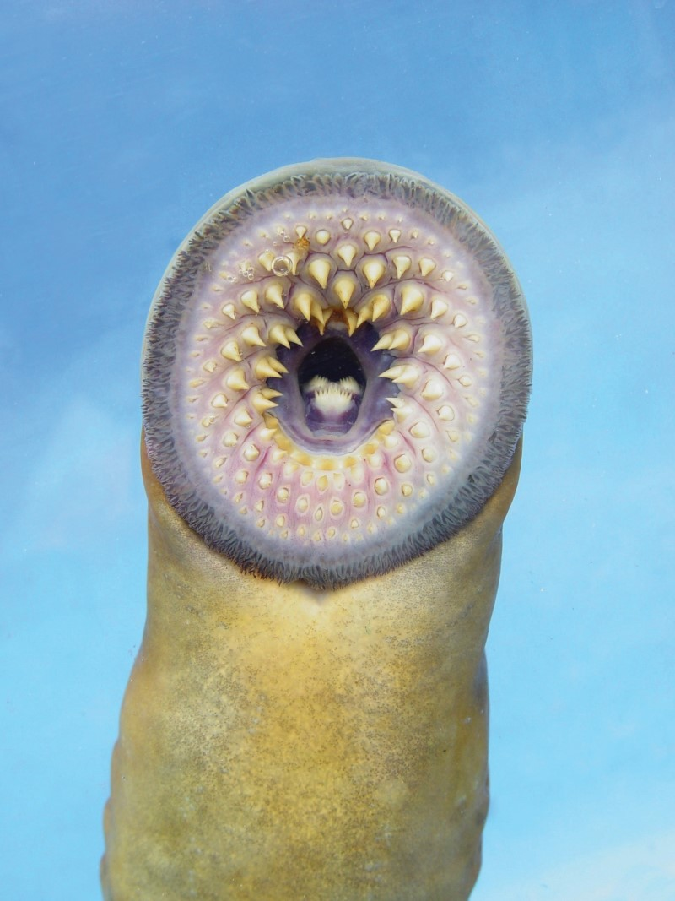

Image resource: Connecticut’s official state website, Department of Energy and Environmental Protection, <https://portal.ct.gov/DEEP/Fishing/Freshwater/Freshwater-Fishes-of-Connecticut/Sea-Lamprey>

* Ancestral vertebrates along with hagfish. (Agnatha** - jawless fish) **super class
* Simple nervous system
* The brain of the sea lamprey has the starting components of the complex vertebrate brain:
  + Forebrain
  + Midbrain
  + Cerebellum
  + Medulla
* How do sea lamprey populations benefit from living in the Great Lakes? What helped them become established?

Characteristics of their morphology, physiology, and behaviors:

* + Sea lampreys have high fecundity (ability to produce a large amount of offspring in one season about 30,000-100,000 eggs)
  + Ammocete (larval stage) is prolonged (3-10 years) with low feeding maintenance allowing them to survive burrowed in the substrate (river bottom) away from predators
  + Sea lampreys have a high tolerance to changes in salinity, osmolarity, and temperature.
* Form follows function - the shape (form) of the structure is influenced by its function.
  + Sharp teeth - adaptive form which allows lampreys to hold onto prey
  + Papilla - allow for the ability to stick on prey

**Resources:**

Wisconsin Sea Grant Identify fish using different body parts (“Lamprey” section) <https://www.seagrant.wisc.edu/fish-id/>

Invasive species Center <https://www.invasivespeciescentre.ca/invasive-species/meet-the-species/fish-and-invertebrates/sea-lamprey/>

External morphology of lampreys <https://www.notesonzoology.com/phylum-chordata/lamprey/external-morphology-of-lamprey-with-diagram-chordata-zoology/7883>

**Native Range (including ecosystem niche/role, e.g., predator-prey relationships, parasitism, etc.)**

* Habitat: marine and freshwater, use rivers to spawn.
* Native Range: Atlantic coast of Labrador to Gulf of Mexico, Florida, Atlantic coast of Europe and the Mediterranean Sea.

Note: Those established in or entering the Great Lakes system will live their entire lives in the Great Lakes.

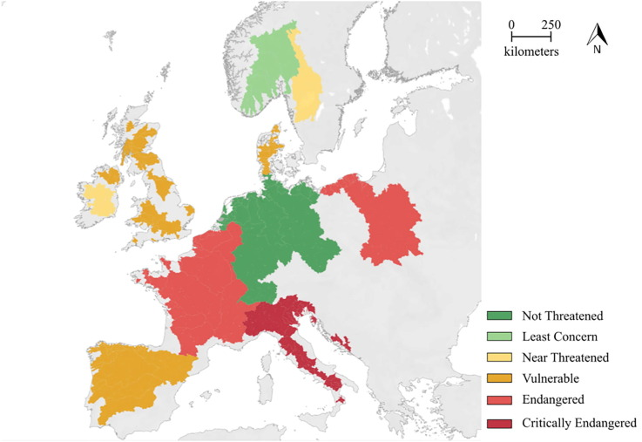

Image resource: Journal of Great Lakes Research: Managing native and non-native sea lamprey (Petromyzon marinus) through anthropogenic change: A prospective assessment of key threats and uncertainties

<https://www.sciencedirect.com/science/article/pii/S0380133020301969>

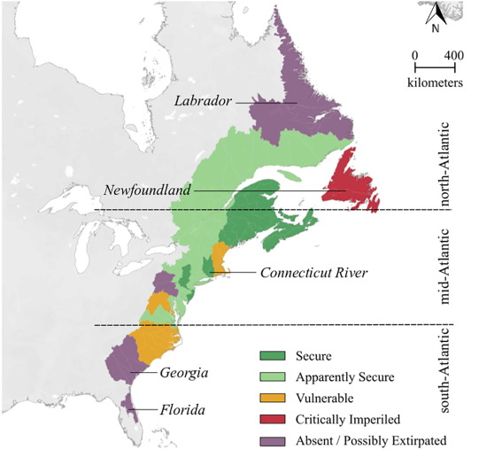

Image resource: Journal of Great Lakes Research: Managing native and non-native sea lamprey (Petromyzon marinus) through anthropogenic change: A prospective assessment of key threats and uncertainties <https://www.sciencedirect.com/science/article/pii/S0380133020301969>

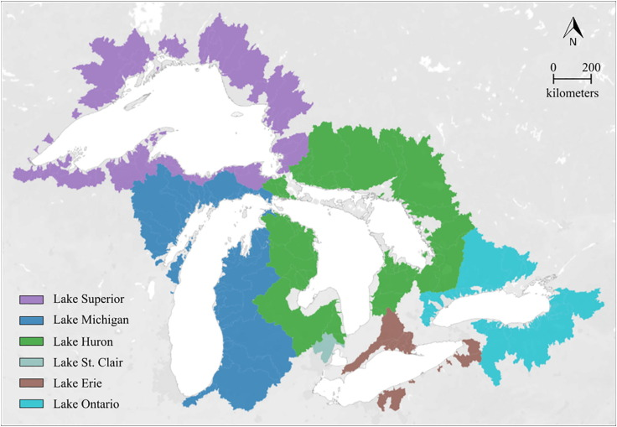

Image resource: Journal of Great Lakes Research: Managing native and non-native sea lamprey (Petromyzon marinus) through anthropogenic change: A prospective assessment of key threats and uncertainties

<https://www.sciencedirect.com/science/article/pii/S0380133020301969>

* In some of the sea lamprey’s native range, they are endangered because of dams, overfishing, pollution, and habitat loss.
* In native ranges, sea lampreys and other native species have evolved amongst each other allowing the sea lampreys to be kept under control naturally.
* In Europe, the European catfish, which is an introduced fish, is a threat to native sea lampreys and is slowly depleting the species from the area (high predation of native sea lamprey during spawning migration)

<https://www.nature.com/articles/s41598-020-62916-w>)

* In the Great Lakes, there are no natural predators or coevolved host species to keep the population in check.

**Resources:**

Invasive species: Sea Lamprey Michigan.gov <https://www.michigan.gov/invasives/id-report/fish/sea-lamprey#:~:text=Native%20Range%3A%20Atlantic%20coast%20from,York%2C%20Pennsylvania%2C%20and%20Wisconsin>.

**History in the Great Lakes**

* The first sighting of sea lampreys in the Great Lakes dates back to the 1800s.
* Lake Ontario was the first discovery of sea lampreys (1835s).
  + sea lampreys migrated to Lake Erie (1921).
* Sea lampreys then used interconnecting streams, rivers, and fish to move throughout the other Great Lakes.
  + By the 1940s sea lampreys were prevalent in all Great Lakes.
* Sea lampreys are currently in all Great Lakes and the surrounding streams affecting many native fish species.

**Resources:**

Great Lakes Fishery Commission

<http://sealamprey.org/pubs/factsheets/FACT%204_14-0913_HR.pdf>

**Life Cycle**

**Atlantic Native range -**

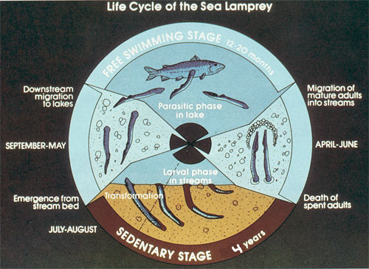

Image resource: New York State Department of Environmental Conservation

<https://dec.ny.gov/nature/animals-fish-plants/sea-lamprey>

**Great Lakes region -**

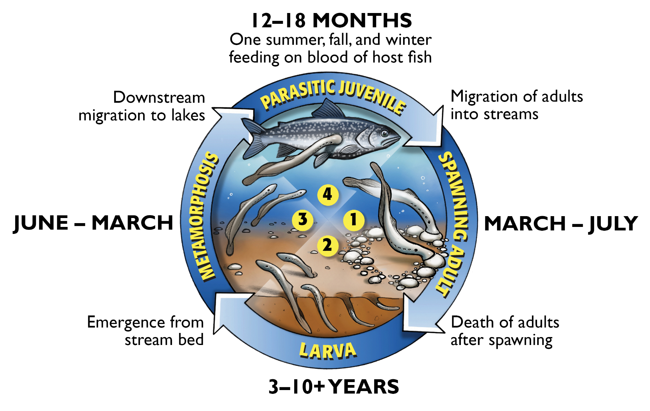

Image resource: Great Lakes Fishery Commission <http://www.glfc.org/sea-lamprey-lifecycle.php#:~:text=During%20the%20winter%20or%20early,and%20die%20shortly%20after%20spawning>.

* Sea lampreys are **diadromous** meaning they spend early life in freshwater streams and rivers then slowly migrate to a large body of water (ocean or a large freshwater lake).
* Adult breeding happens in streams and lakes.
* Two main life phases:
  + Sedentary (larval) phase
  + Free swimming (parasitic juvenile and adult) phase
* In the larval phase, sea lampreys are called **ammocoetes.** 
  + This stage usually lasts 3-4 years but could last as long as 10 years
  + Ammocoetes are:
    - blind and worm-like;
    - found in streambeds or banks;
    - eat drifting algae or other microscopic materials;
    - are not parasitic.
* After the larval phase, the ammocoetes will transform.
  + Transformation begins when larval sea lampreys develop eyes and a suction disc mouth.
  + At this stage they look like miniature adults.
  + This change initiates the process to allow them to survive in saltwater (though they can continue to live in freshwater systems).
* Once the newly-transformed sea lampreys reach the lake or ocean, they enter the free-swimming parasitic phase.
  + This stage can last from 12-20 months.
  + Sea lampreys parasitize fish at this stage by attaching using their disc mouth and breaking through fish scales and skin with their rasping tongue.
  + This is the stage that is most harmful to fishes in the Great Lakes since sea lampreys feed on many species over long periods of time and drain the host’s body fluids.
* As the parasitic phase declines, a sea lamprey becomes a full adult and is ready to return to its natal stream to spawn.
  + In the Great Lakes this is usually from March to July
  + After spawning, sea lampreys die.
* Sea lampreys in the Great Lake system do not migrate out into the ocean, instead, they stay in the Great Lakes.

**Resources:**

Sea lamprey biology and life stages

New York State Department of Environmental Conservation: <https://dec.ny.gov/nature/animals-fish-plants/sea-lamprey>

Great Lakes Fishery Commission: <https://www.glfc.org/sea-lamprey.php>

**Impact on Great Lakes Ecosystems**

* During their parasitic (juvenile) phase, sea lampreys can kill up to 40 pounds (18 Kilograms) of fish.
* Most fish that have a sea lamprey attached will not survive the parasitism due to malnutrition (bodily fluids drained) or infection of the open wound where the mouth was attached.
* A primary reason sea lampreys have negative effects in Great Lakes ecosystems is lack of natural predators and an abundant food source of Great Lakes fishes. Sea lampreys and native Great Lakes fish did not evolve within the same ecosystem so native fish have no natural defenses against sea lampreys and sea lampreys have no natural predators in the Great Lakes.
* Great Lakes fishes are not as large and have smaller population densities in comparison to the oceans such that they are not equipped to handle sea lampreys predation as effectively. Therefore fish populations in the Great Lakes are rapidly reduced.

**Resources:**

Great Lakes Fishery Commission

<http://sealamprey.org/pubs/factsheets/FACT%204_14-0913_HR.pdf>

Michigan State University (Greats Lakes Sea Lamprey control) <https://www.canr.msu.edu/news/great_lakes_sea_lamprey_control_is_critical_msg18_kinnunen18#:~:text=The%20Great%20Lakes%20Fishery%20Commission,about%20%243%20million%20for%20chemicals>.

**Impact on Great Lakes Economies**

* An entire economic fishing industry is developed around lake trout from both the United States and Canada.
  + Lake trout play a vital role as a top predator in maintaining the food web and populations of the Great Lake ecosystem.
  + Sea lampreys caused a large decline in fisheries of the Great Lakes. In 1961 total Lake Superior catch declined to 368,000 pounds from 4.5 million pounds in a year.
* To combat this, humans have researched and implemented various defenses against and control of sea lampreys costing over 10-20 million dollars per year.

Note: see “Methods of Control” section

* Sea lampreys provide no economic benefits to the Great Lakes.

**Resources:**

Great Lakes Fishery Commission

<http://sealamprey.org/pubs/factsheets/FACT%204_14-0913_HR.pdf>

Michigan State University (Greats Lakes Sea Lamprey control) <https://www.canr.msu.edu/news/great_lakes_sea_lamprey_control_is_critical_msg18_kinnunen18#:~:text=The%20Great%20Lakes%20Fishery%20Commission,about%20%243%20million%20for%20chemicals>.

**Methods of Control**

* Lampricides:
  + target larval sea lamprey
  + are the most used and effective of the sea lamprey control methods
  + 3-trifluoromethyl-4-nitrophenol (TFM):
    - kills larval sea lampreys before they form the parasitic mouths;
    - will not affect native lampreys in the same stream; and
    - will not affect the chemical makeup of the treated stream.
  + Bayluscide:
    - Can kill sea lamprey larvae in 1-2 hours
    - is a granular lampricide applied in slow-moving or deep water due to its ability to sink to the bottom of the water;
    - may be used independently or along with TFM treatments; and
    - is less expensive than TFM treatments.
* Barriers:
  + inhibit a sea lamprey’s ability to migrate to spawning areas;
  + create walls which block the jumps and movement of sea lampreys;
  + are placed along Great Lakes stream systems to trap and sort native fishes and sea lampreys that try to pass through.
* Pheromones and alarm cues:
  + are natural chemicals that sea lampreys and other organisms release into the environment;
  + are used to attract mates (pheromones) or send other sea lampreys danger signals (alarm cues);
  + utilized to lure adults into unsuitable spawning areas or toward a trap; or
  + detract sea lampreys from suitable spawning habitats.
* Traps:
  + target migrating spawning adults;
  + work with barriers since they are typically placed near or downstream of barriers;
  + are not the most effective control method but allow scientists to gather adult spawning information on sea lampreys.

**Resources:**

Sea Lamprey Control in the Great Lakes by the Great Lakes Fishery Commission

<http://www.glfc.org/pubs/factsheets/FACT%205_all.pdf>

**Career Pathways Associated with Sea Lamprey Study and Control**

* Though sea lampreys hinder the ecosystem and fishing economy they provide jobs and career opportunities to fisheries and wildlife biologists.
* Many biological stations from the United States Fish and Wildlife Service (USFWS) and Department of Natural Resources (DNR) employ sea lamprey control teams that work on identifying regions of necessary control, monitor controlled areas, and deploy control methods.
* Chemists are needed to analyze, synthesize, and test chemical treatments.

Note: more than 6,000 chemicals were tested as potential lampricides before **two** were determined successful and safe for the environment. Source: Sea Lamprey Control Fact Sheet 5 page 4, <http://www.glfc.org/pubs/factsheets/FACT%205_all.pdf>

**Additional background and Research**

**Scientific Studies involving Sea Lamprey**

ScienceDirect Journal of Great Lakes Research:

* Potential for Carbon dioxide to act as a non-physical barrier for invasive sea lamprey movement. <https://www.sciencedirect.com/science/article/pii/S0380133015002117>
* Exploiting the physiology of lampreys to refine methods of control and conservation <https://www.sciencedirect.com/science/article/pii/S0380133021002343>

# Managing native and non-native sea lamprey (*Petromyzon marinus*) through anthropogenic change: A prospective assessment of key threats and uncertainties -<https://www.sciencedirect.com/science/article/pii/S0380133020301969#f0005>

# National Library of medicine:

* Lamprey: a model for vertebrate evolutionary research. <https://www.ncbi.nlm.nih.gov/pmc/articles/PMC5071338/>

Nature.com scientific reports

# High predation of native sea lamprey during spawning migration<https://www.nature.com/articles/s41598-020-62916-w>

**Government Sites:**

* Invasive species: Sea Lamprey Michigan.gov. <https://www.michigan.gov/invasives/id-report/fish/sea-lamprey#:~:text=Native%20Range%3A%20Atlantic%20coast%20from,York%2C%20Pennsylvania%2C%20and%20Wisconsin>
* New York State Department of Environmental Conservation

<https://dec.ny.gov/nature/animals-fish-plants/sea-lamprey#:~:text=Juvenile%20parasitic%20sea%20lamprey%20are,mottled%20dark%20brown%2Fblack%20pigmentation>.

**Websites:**

* Wisconsin Sea Grant Identify fish using different body parts <https://www.seagrant.wisc.edu/fish-id/>
* Invasive species Center <https://www.invasivespeciescentre.ca/invasive-species/meet-the-species/fish-and-invertebrates/sea-lamprey/>
* British Sea Fishing<https://britishseafishing.co.uk/sea-lamprey/>
* External morphology of lamprey <https://www.notesonzoology.com/phylum-chordata/lamprey/external-morphology-of-lamprey-with-diagram-chordata-zoology/7883>
* Michigan State University (Greats Lakes Sea Lamprey control) <https://www.canr.msu.edu/news/great_lakes_sea_lamprey_control_is_critical_msg18_kinnunen18#:~:text=The%20Great%20Lakes%20Fishery%20Commission,about%20%243%20million%20for%20chemicals>

**Information flyers/fact sheets:**

* Sea Lamprey Control in the Great Lakes by the Great Lakes Fishery Commission <http://www.glfc.org/pubs/factsheets/FACT%205_all.pdf>
* Foundational resources are the *Sea Lamprey Fact Sheets* from the Great Lakes Fishery Commission: <https://sealamprey.org/fact-sheets.php>