**Warning Signs: Teacher Example**

Name:___________________

Pick a Michigan Invasive species: European Frog-bit (EFB)

List characteristics of the species that stick out the most to you. Examples might be: color; shape; height; patterns; etc.

* European frog-bit clumps together as a floating dense mat of leaves
* It has round or heart-shaped leaves
* The leaves may have purple red underside
* Multiple leaf stems connect at the middle to the roots (“rosette”)
* Rosettes typically have 1 single flower with three white petals and a yellow center

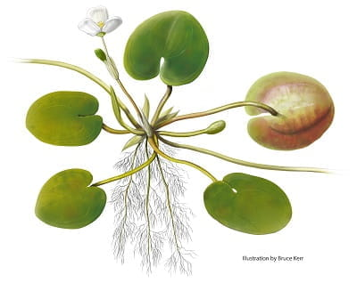

Image and textual resource taken from Michigan invasive Species: European Frog-bit <https://www.michigan.gov/invasives/id-report/plants/aquatic/european-frog-bit>

List reasons why this invasive species is an issue in this region. For example, does it hurt other plants or animals, take over spaces, is it dangerous to humans?

* EFB can block paths for recreational water activities such as kayaking, swimming, boating, hunting, and fishing
* Dense leaf mats can get tangled in boat propellers
* EFB can reduce oxygen and light in the water
* EFB can drown turtles or other small animals that live in or near the water
* EFB alters food and habitat for ducks, fish, and aquatic mammals

What other species look similar to this organism and describe how you tell the difference.

EFB can be mistaken for miniature water lilies but water lilies are well rooted to water bottom, not free-floating, and have larger leaves

What should people be advised about this species? Should they remove it and interact with it or is this something people need to avoid due to its dangers?

If you come in contact with European frog-bit you should take a picture and record its location and report this to the Michigan Department of Environment Great Lakes and Energy (EGLE) aquatic invasive species program [EGLE-WRD-AIP@Michigan.gov](mailto:EGLE-WRD-AIP@Michigan.gov).

Remember to decontaminate all equipment before leaving an aquatic area to stop the spread!

**Create a warning sign!**

*Keep in mind why you are creating this warning sign. Is it because the organism is dangerous to people or to help people find and identify it compared to its look-alikes or are there other reasons?*

Your warning sign should include these components:

* The name of the invasive species
* A picture (or pictures) of the species (possibly your drawings or photographs)
* A descriptive identification key for at least three features or characteristics that help identify the species
* Non-invasive look-alike species:
  + briefly describe three differences between the invasive and non-invasive look-alike species
  + include a picture of the look-alike species
* Describe the health concerns or danger and what to do if someone encounters the invasive species
* Describe at least two preventative actions to help stop the species spread

**See the Warning Signs rubric for grading considerations for each requirement.**