

Navigating Your Role as a New Board Member

MCCSA Webinar – September 2026
The Governance Compass – Quick Reference Guide

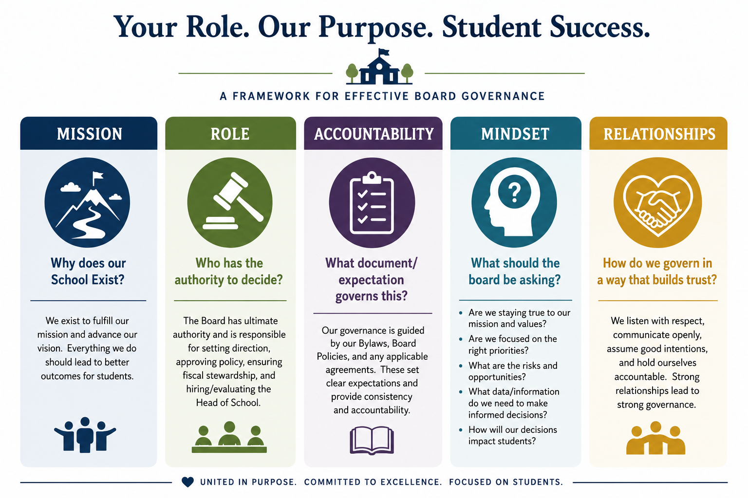

Before I act, ask:

Is this aligned with our mission?
Is this within the Board's role?
Does this support students?
Is it financially responsible?
Does it comply with our charter?

My role is not to run the school. My role is to help govern it well!

